Experiment 1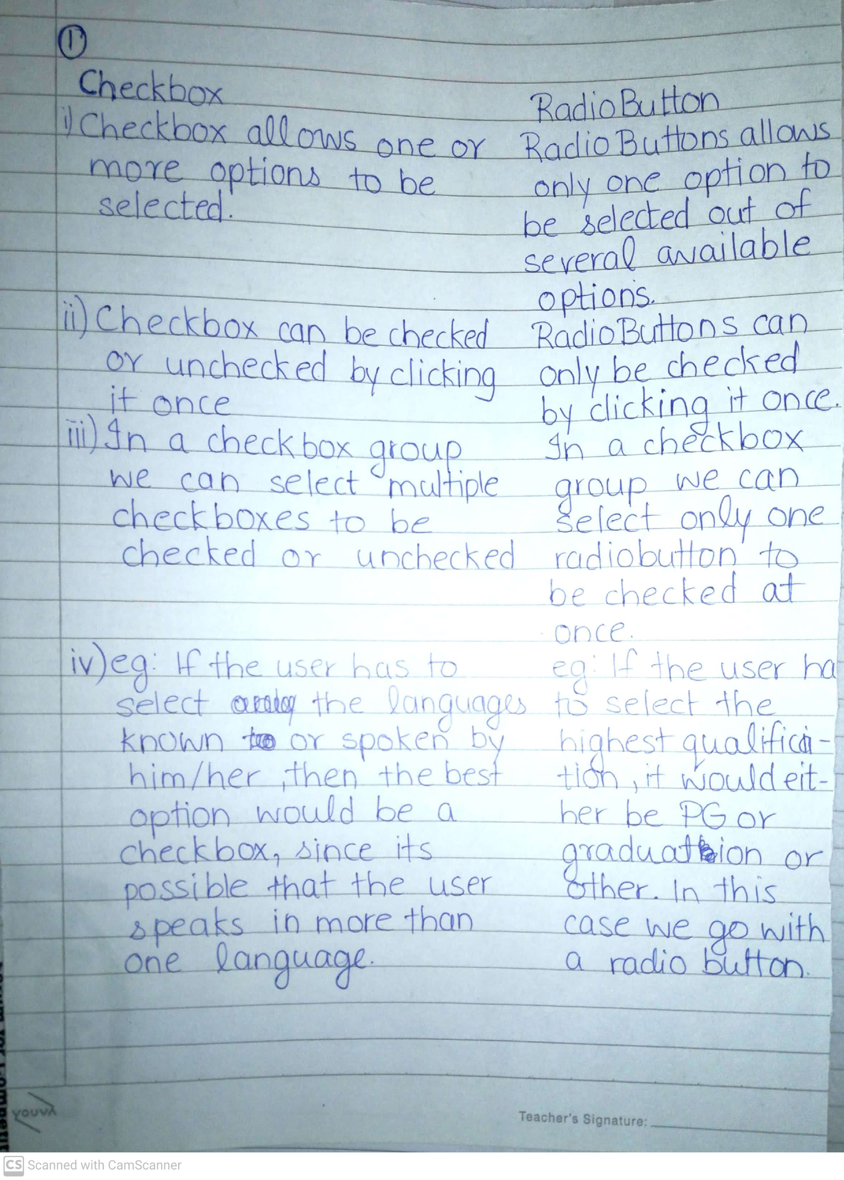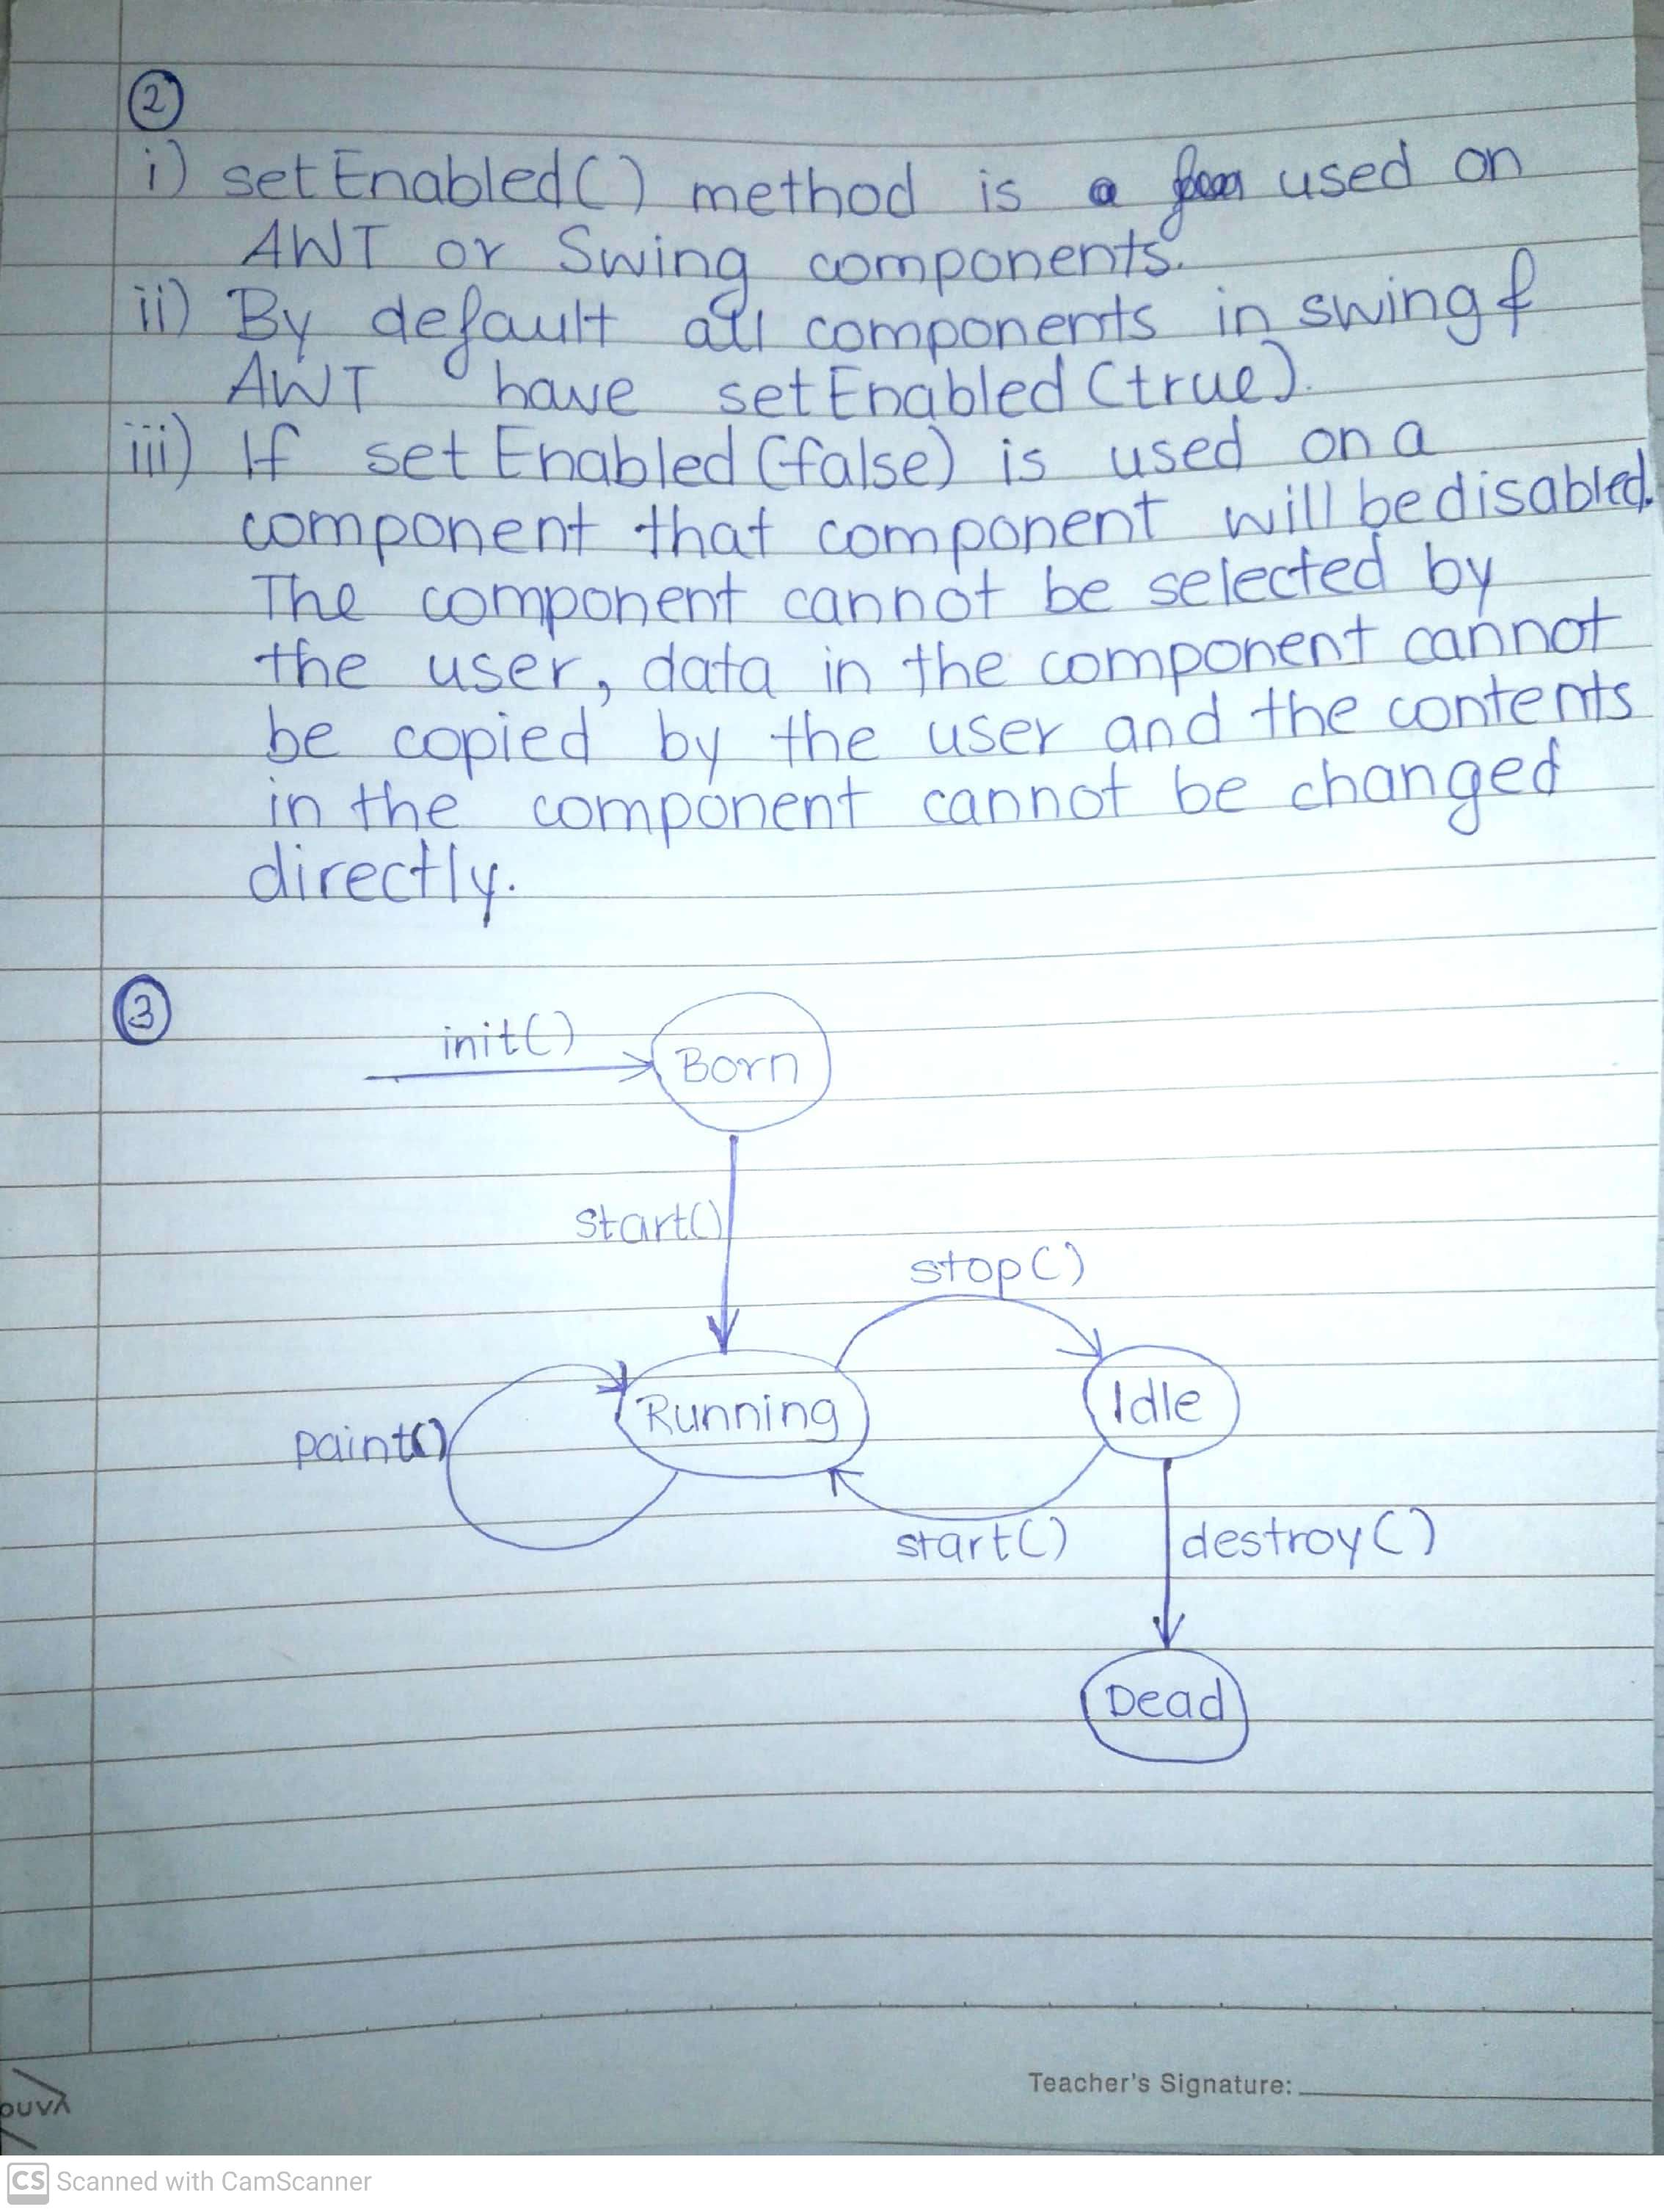

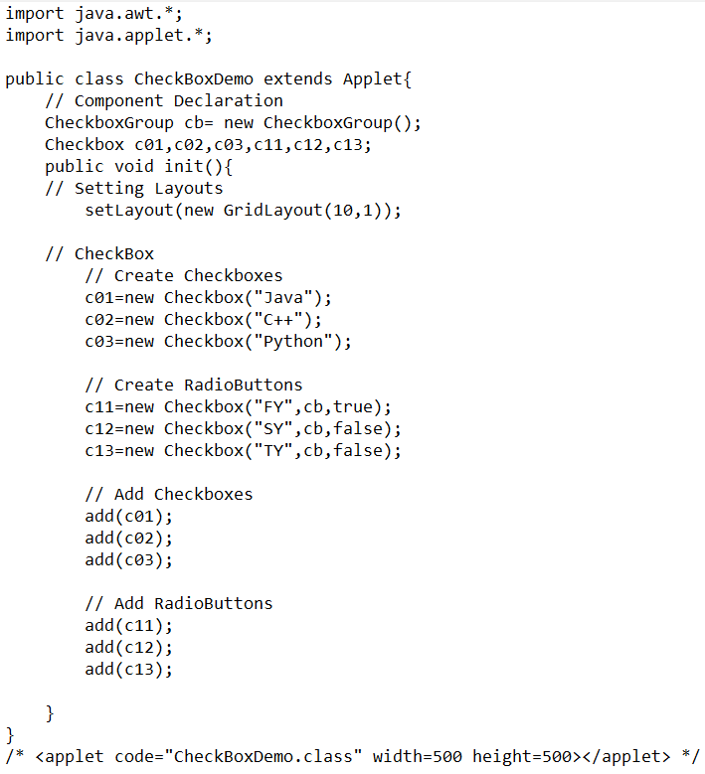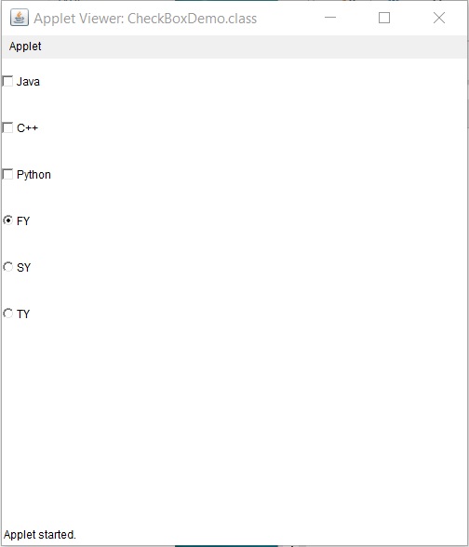

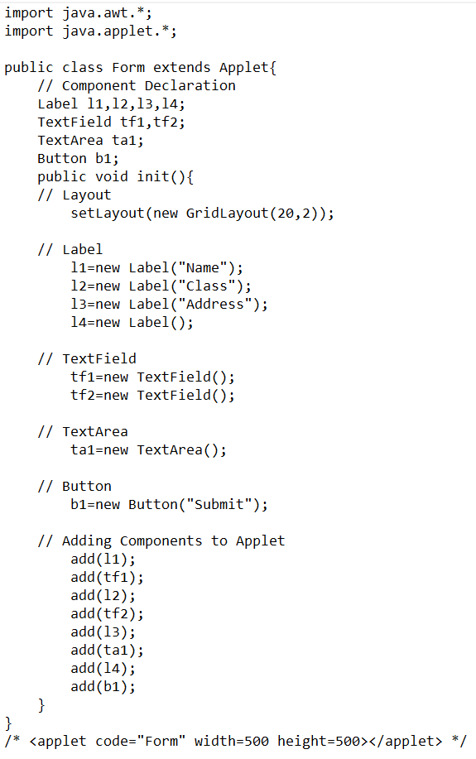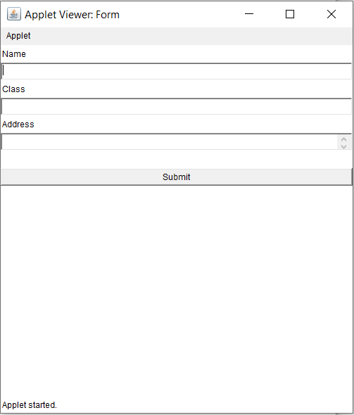

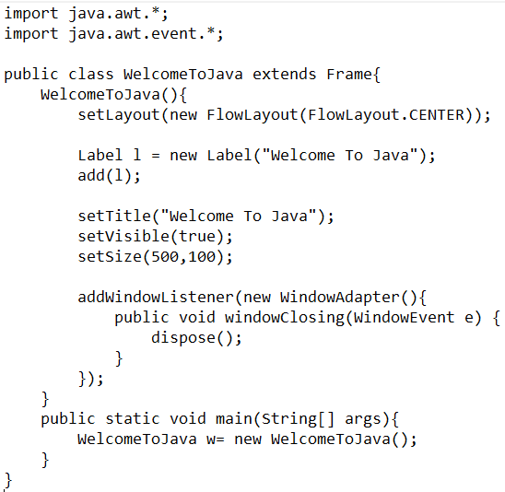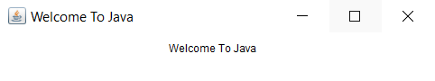

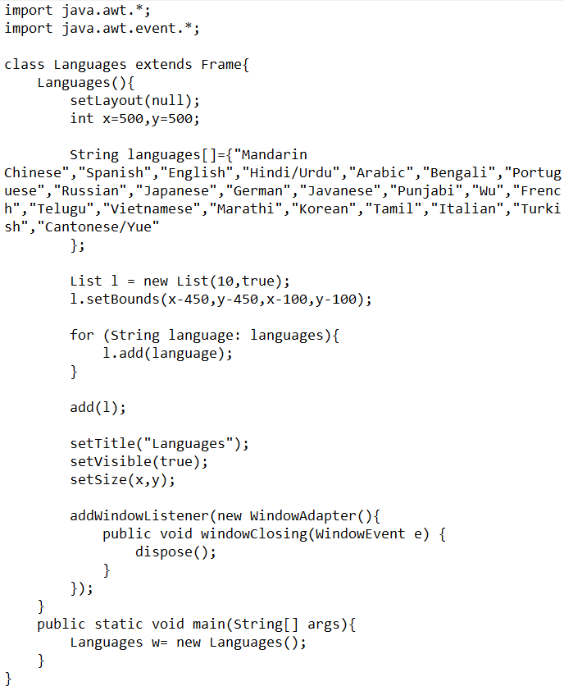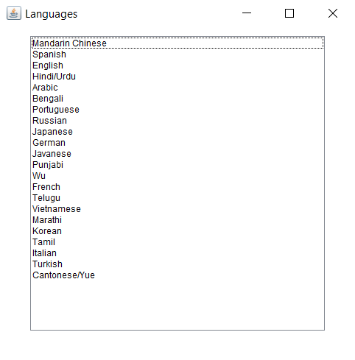

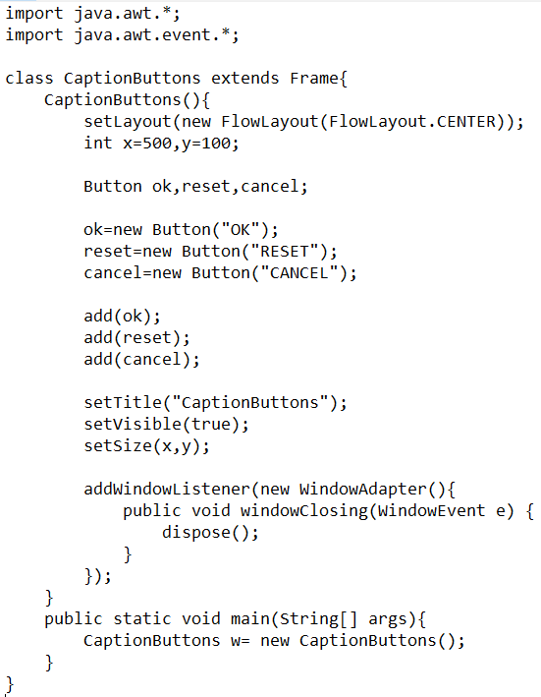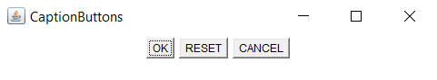

Experiment 2

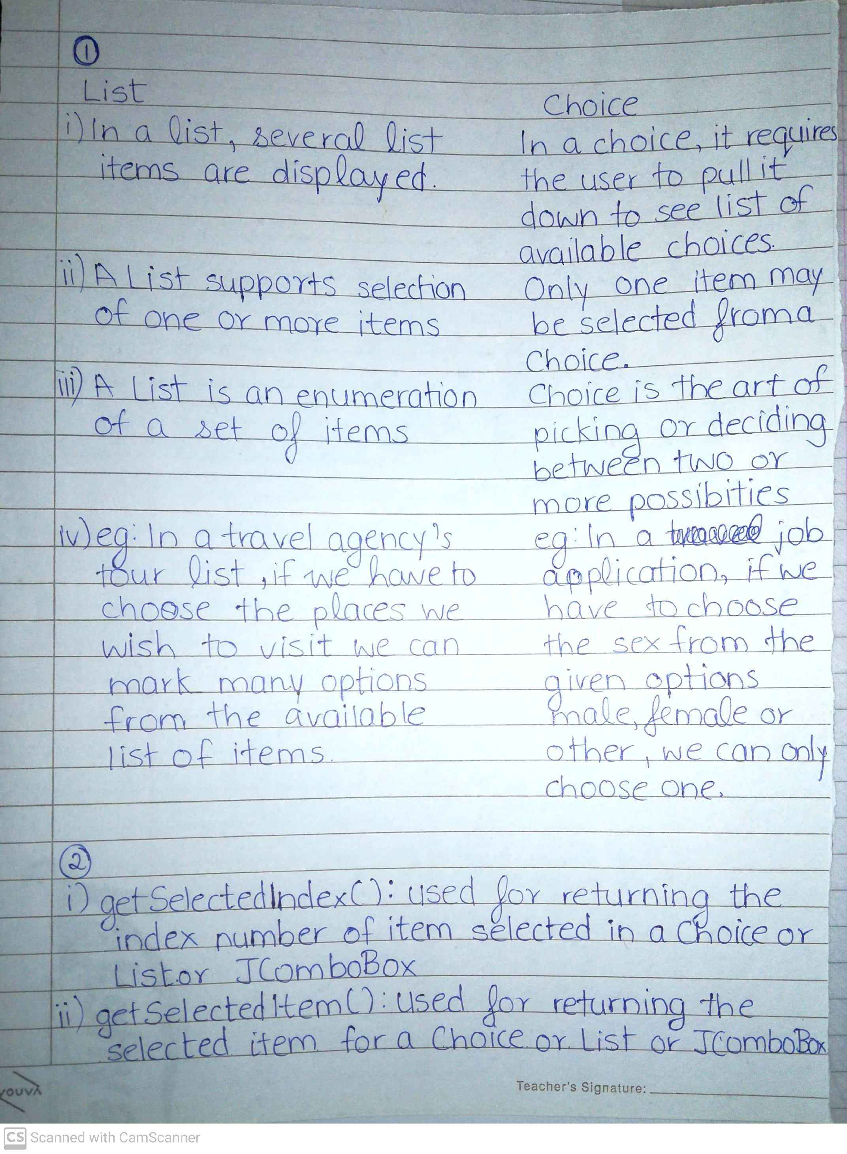

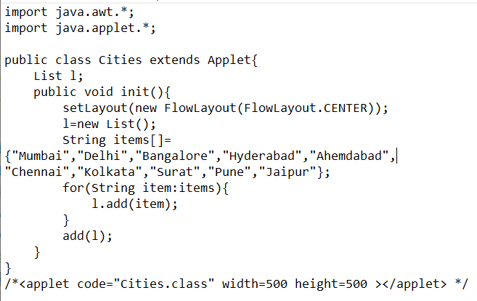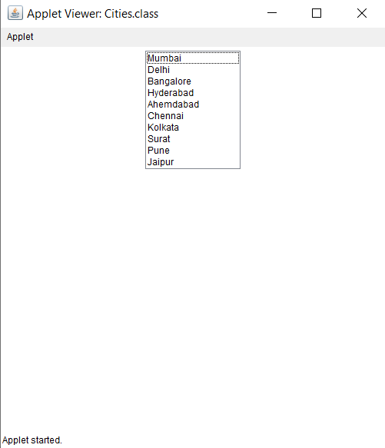

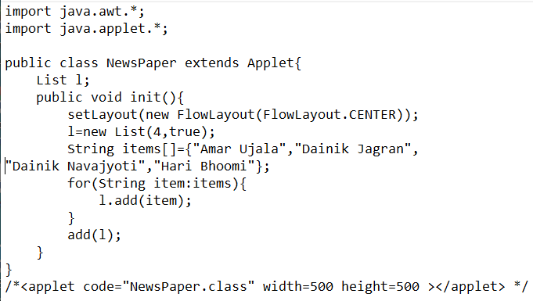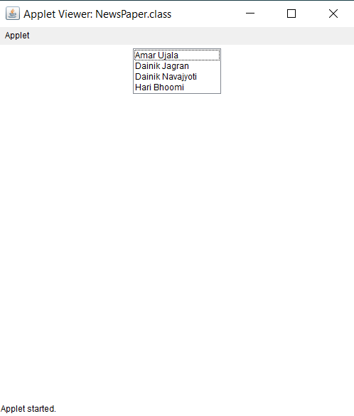

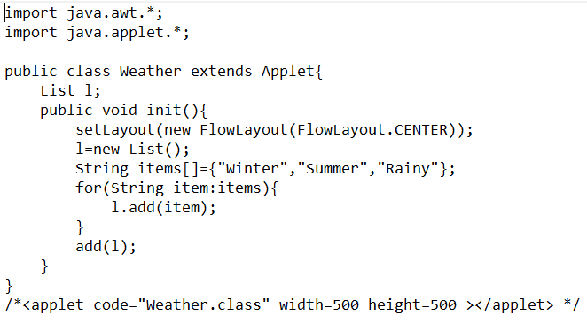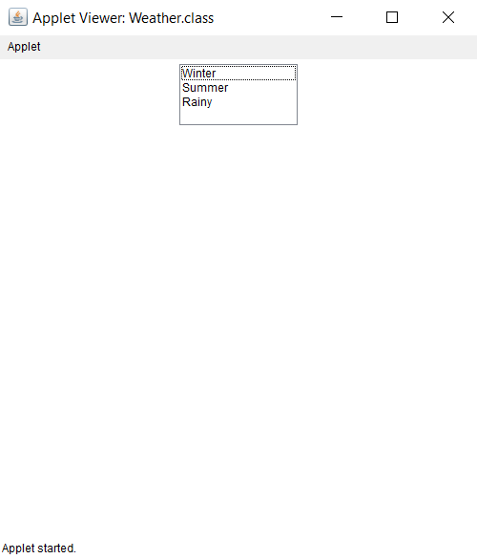

Experiment 3

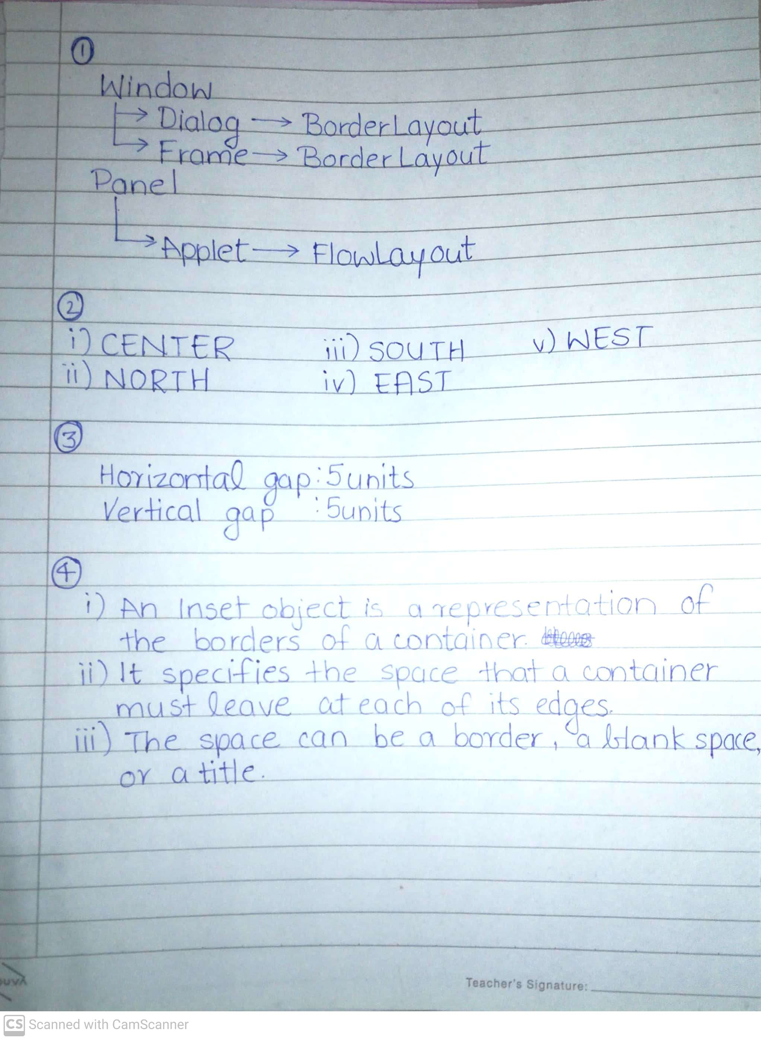

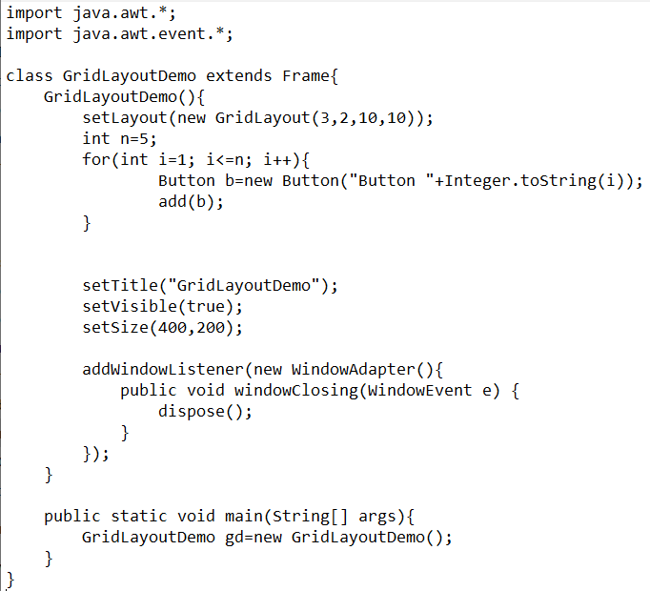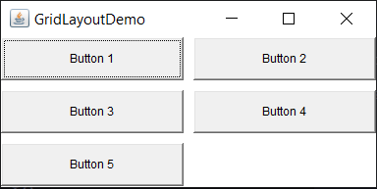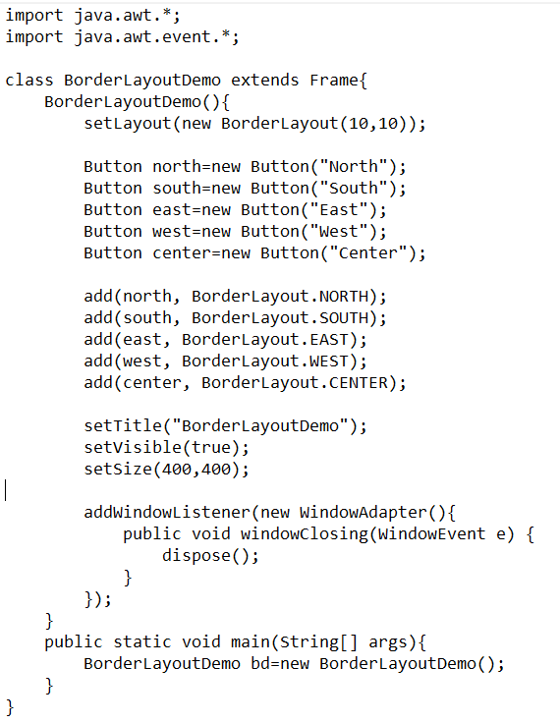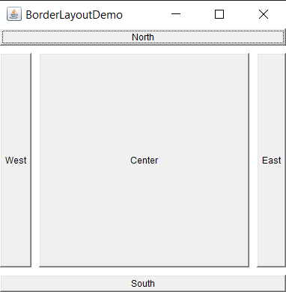

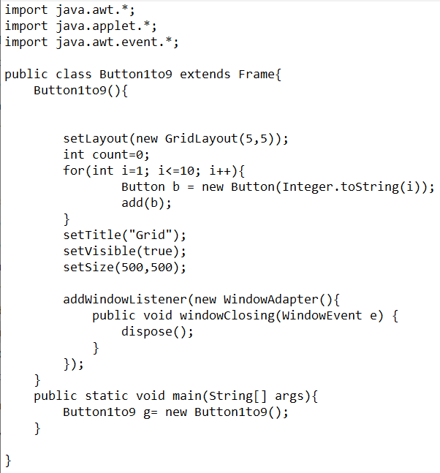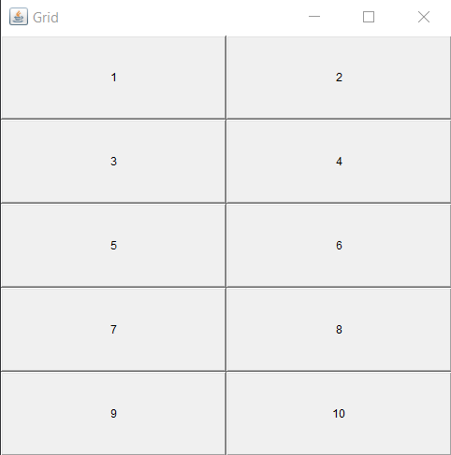

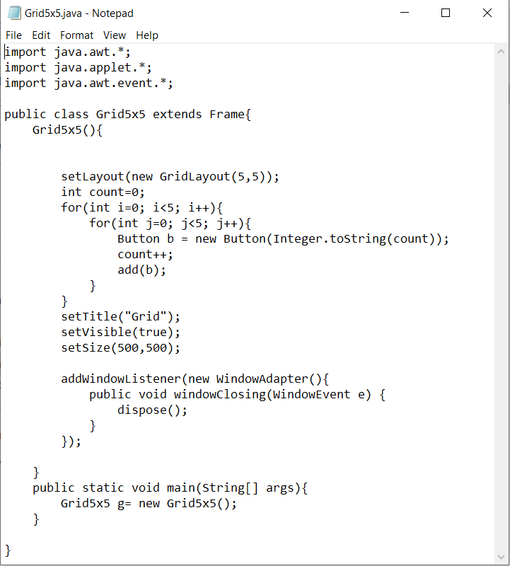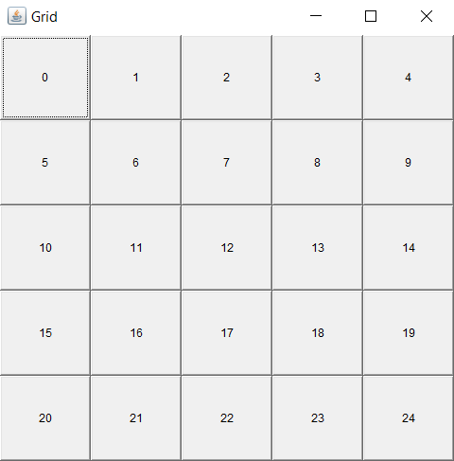

Experiment 4

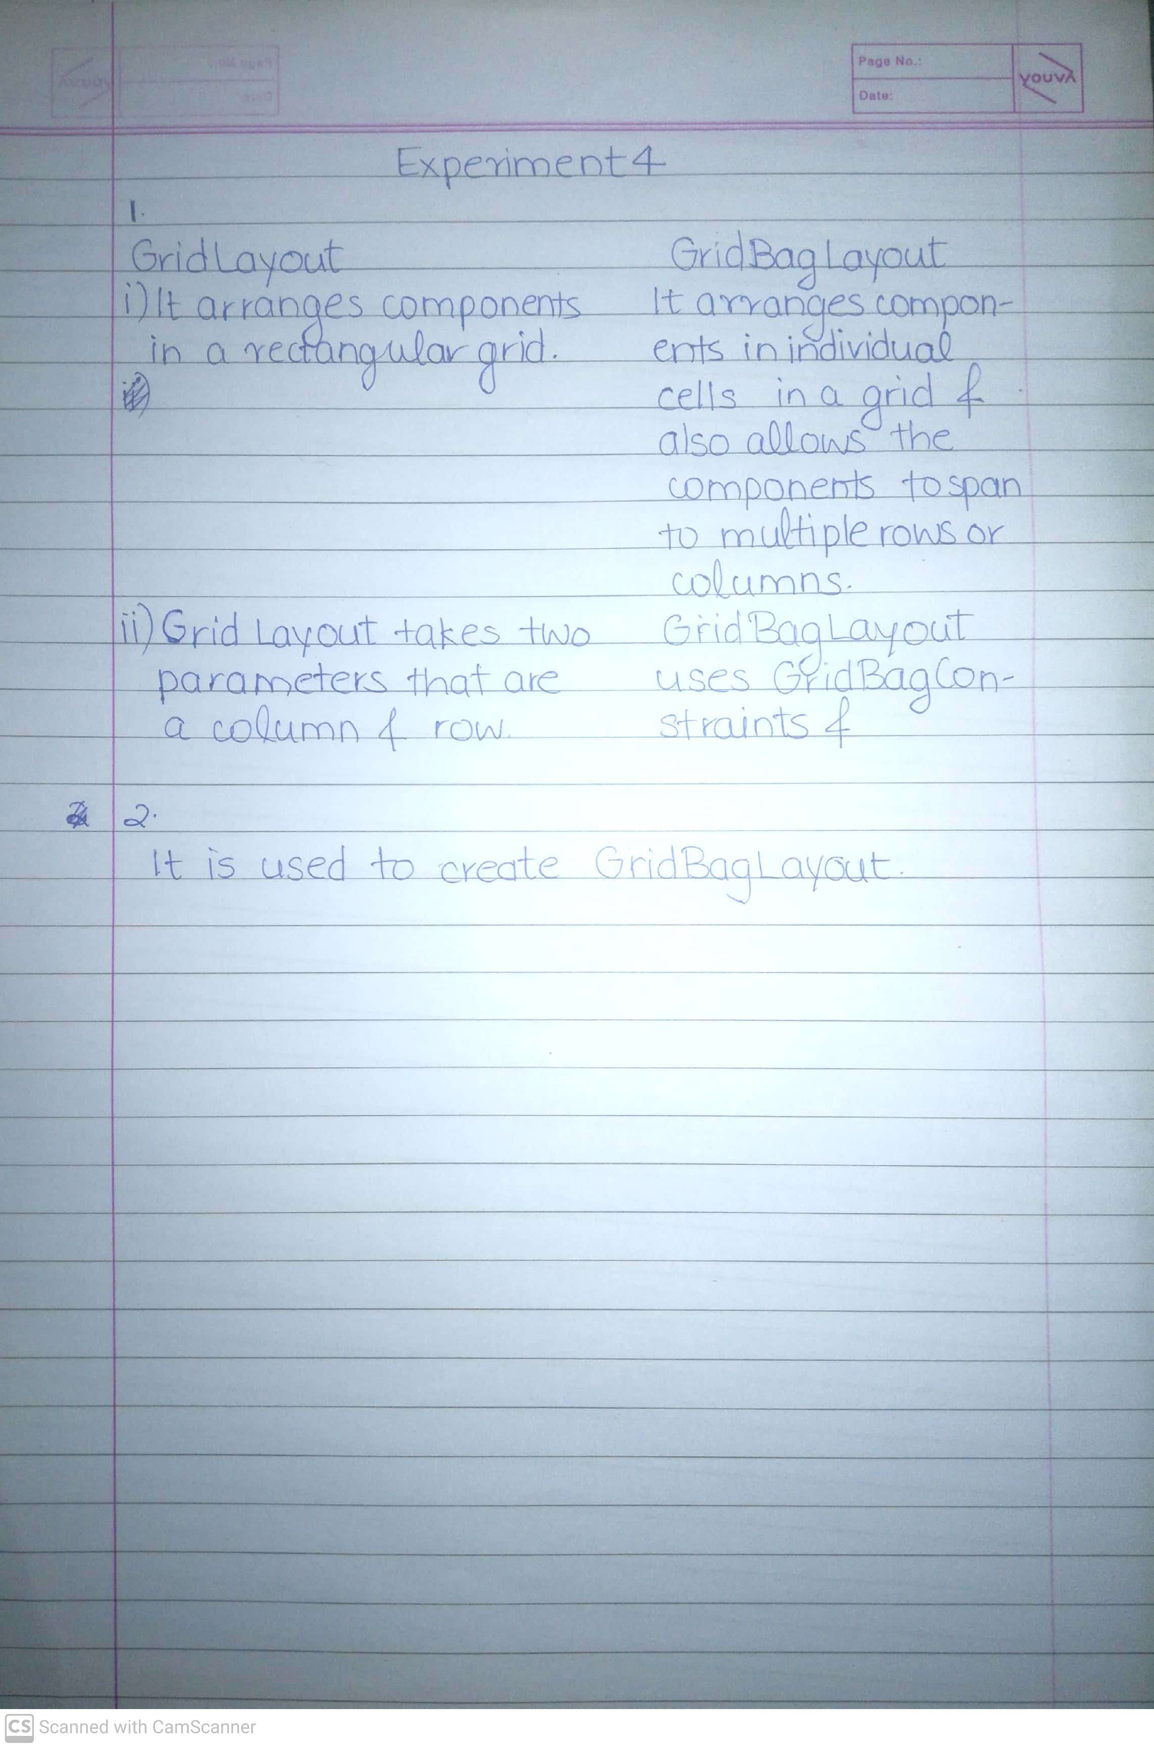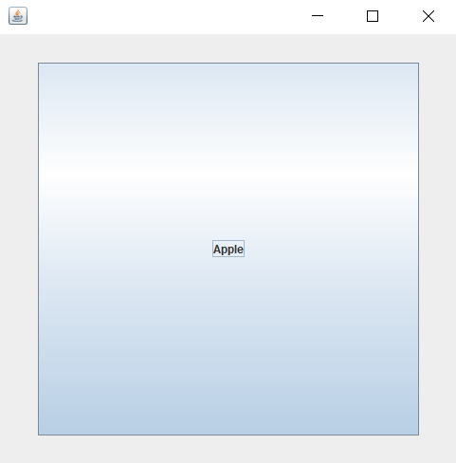

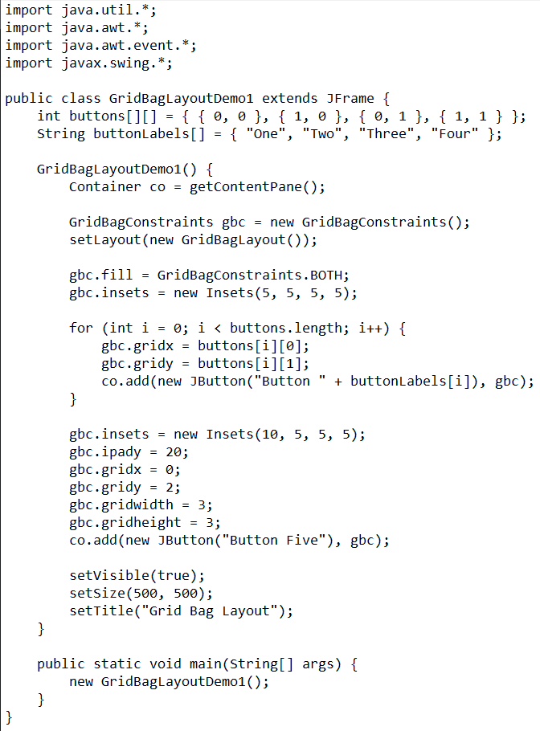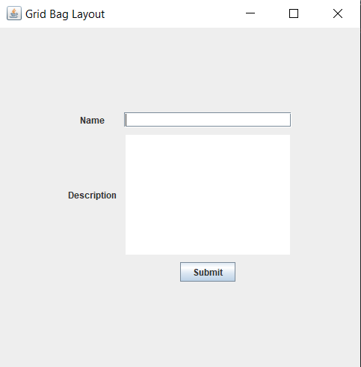

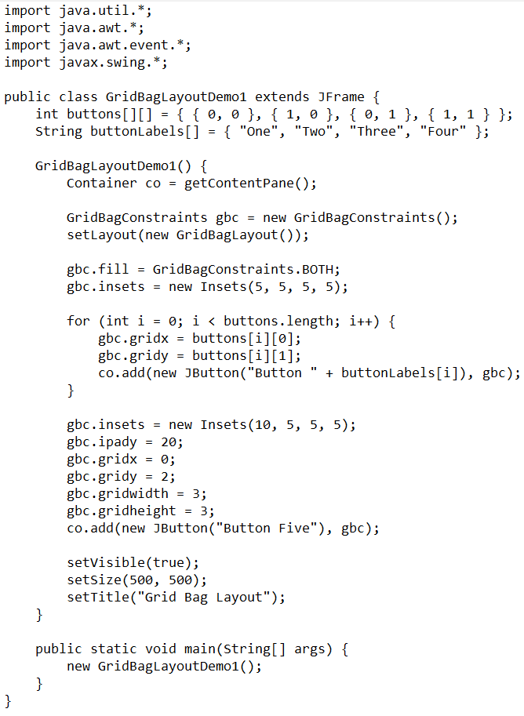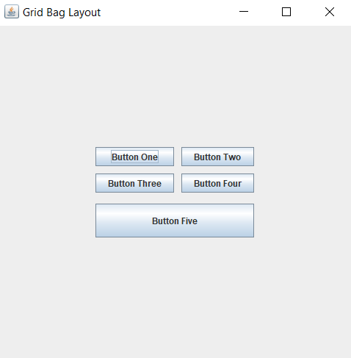

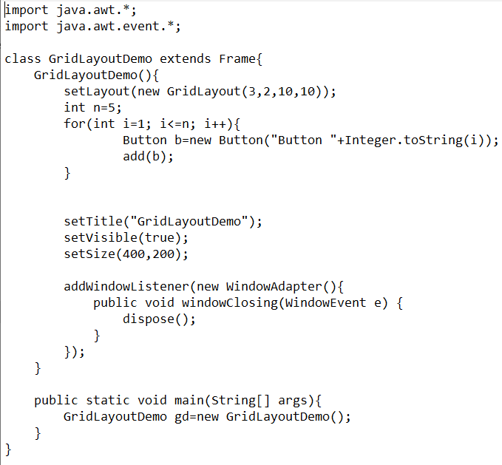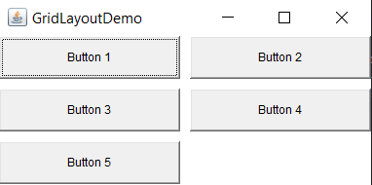

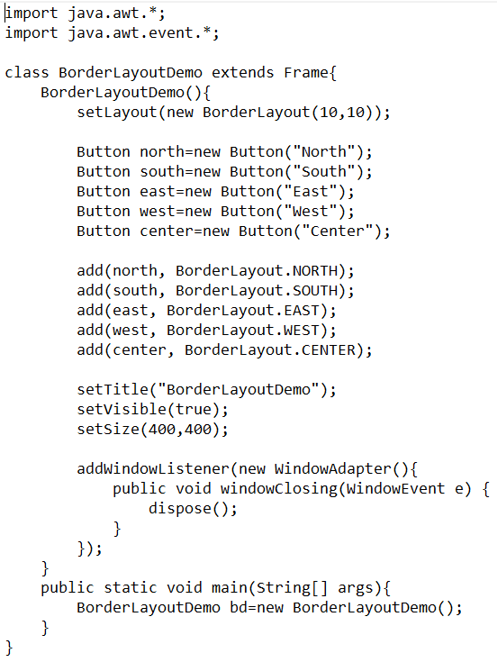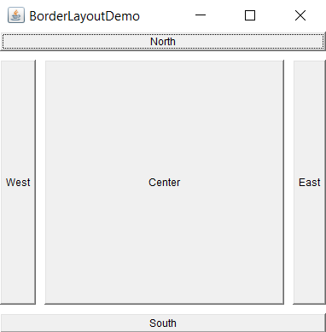

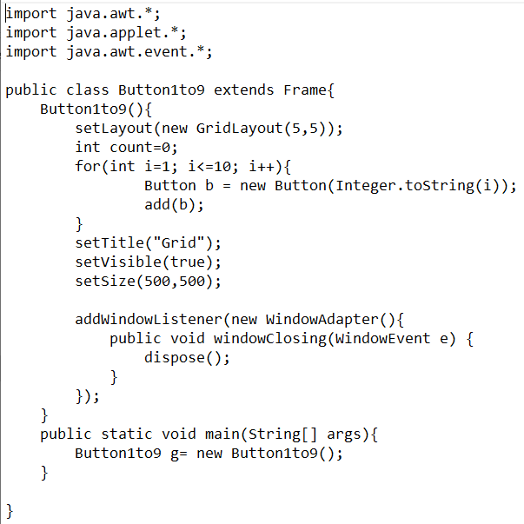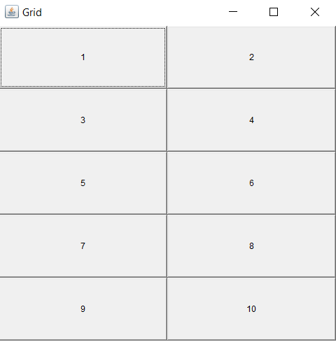

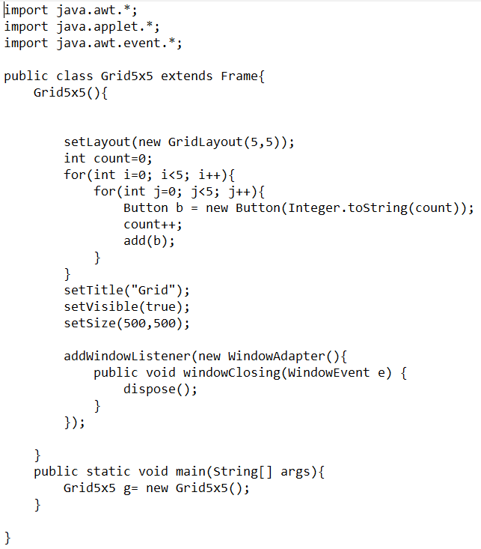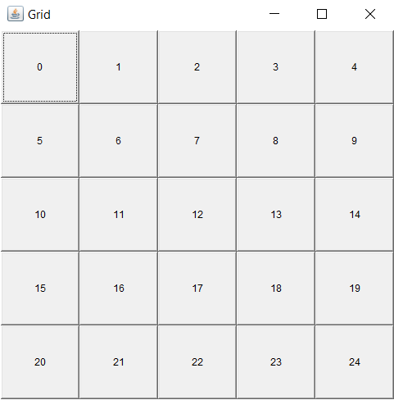

Experiment 5

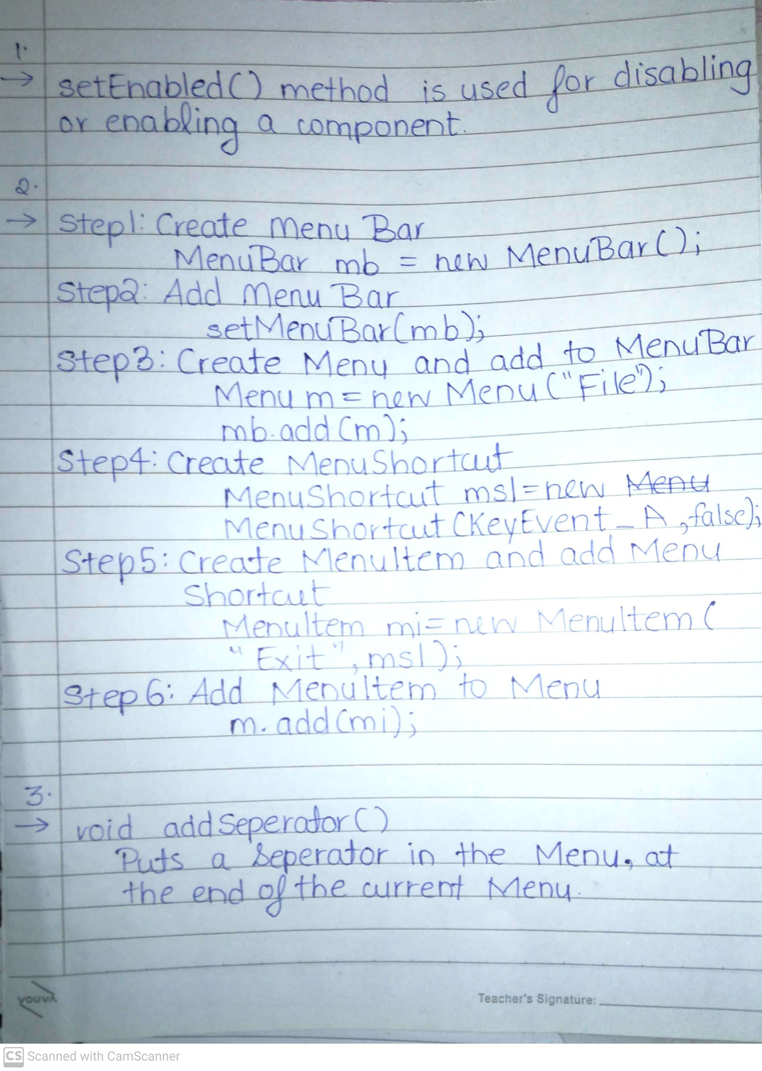

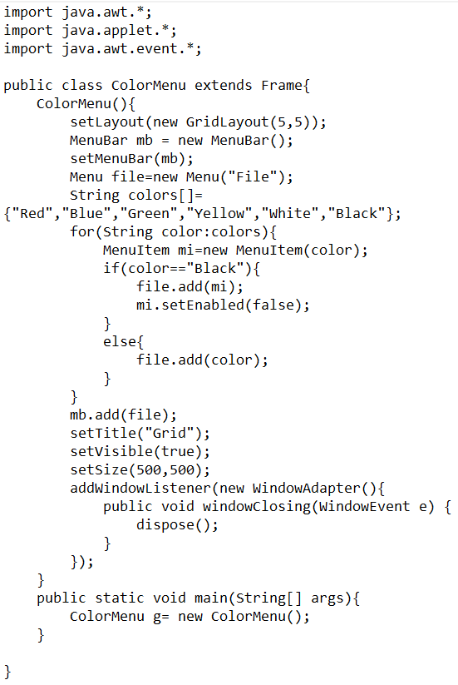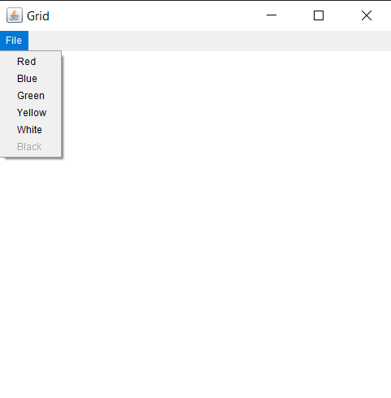

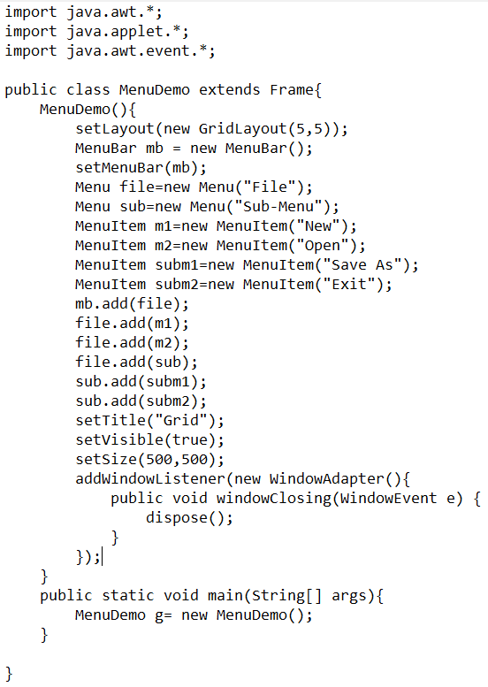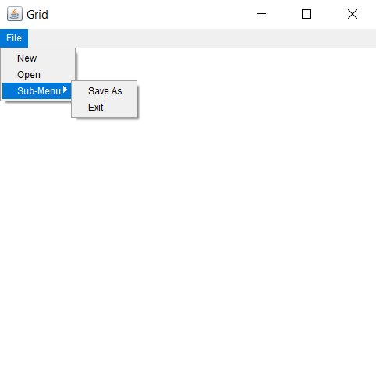

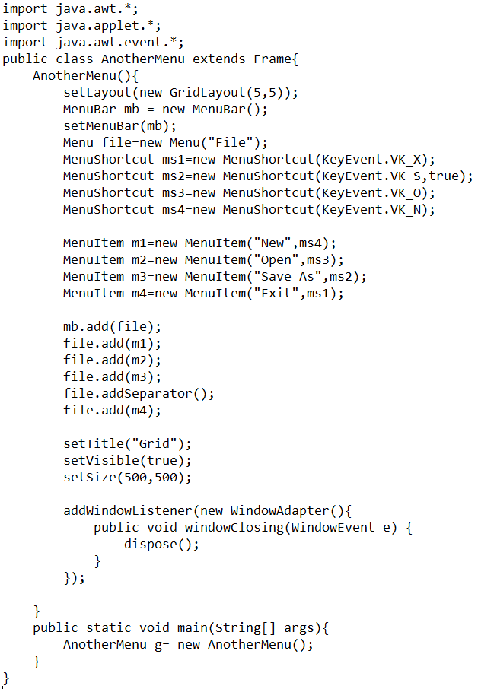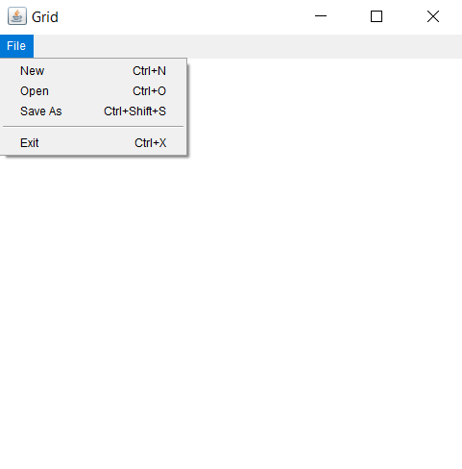

Experiment 6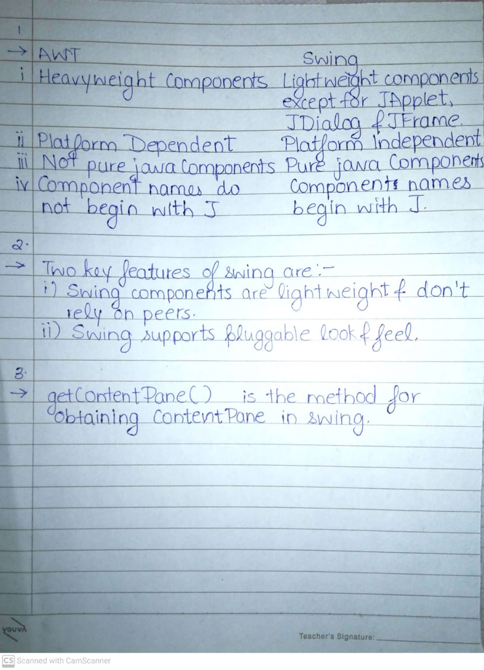

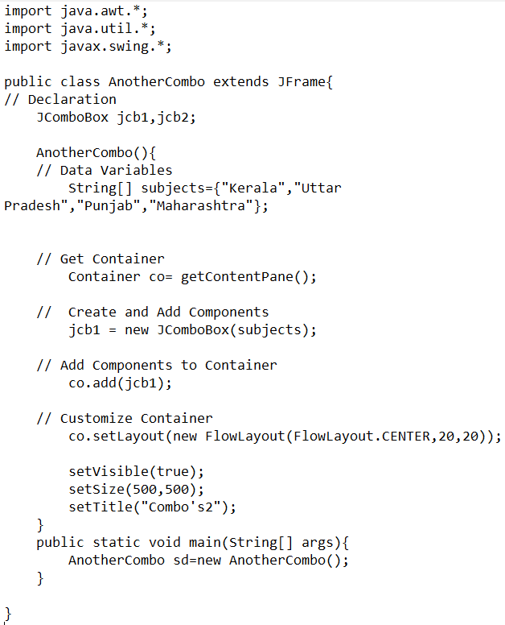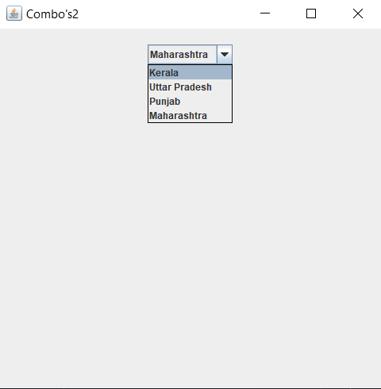

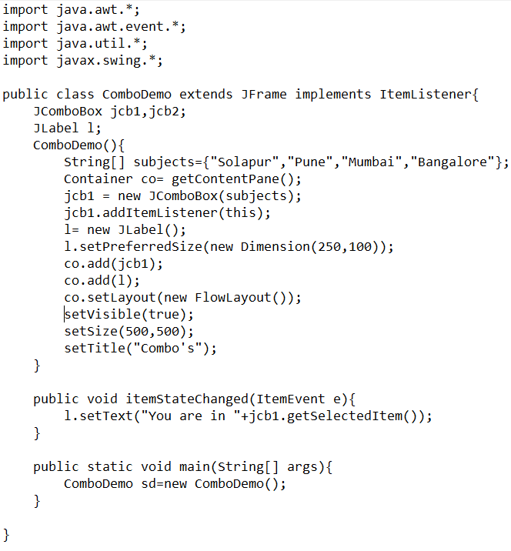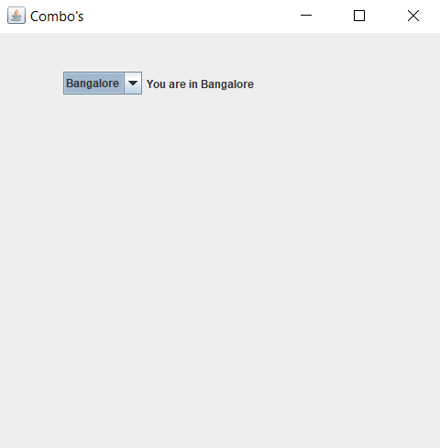

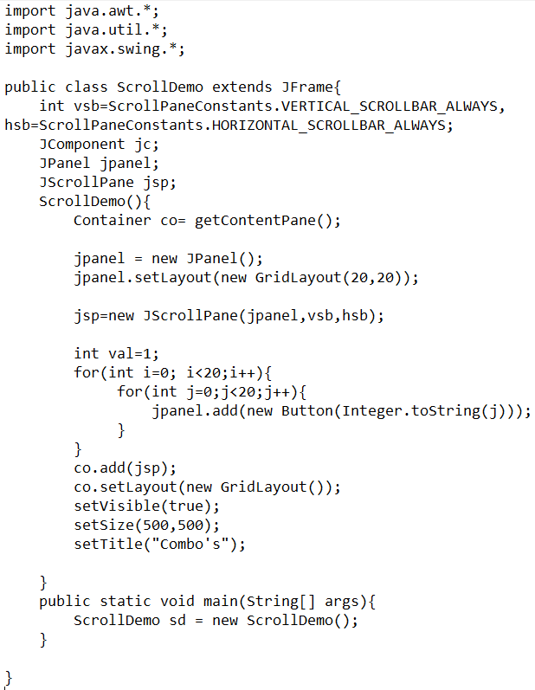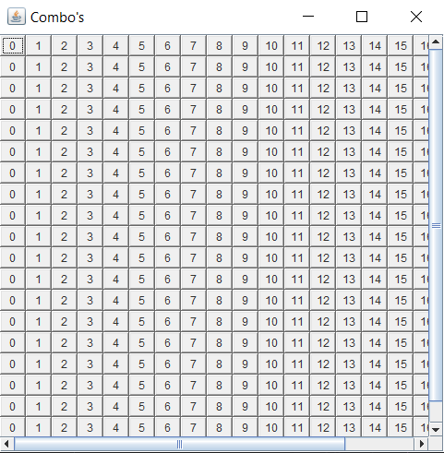

Experiment 7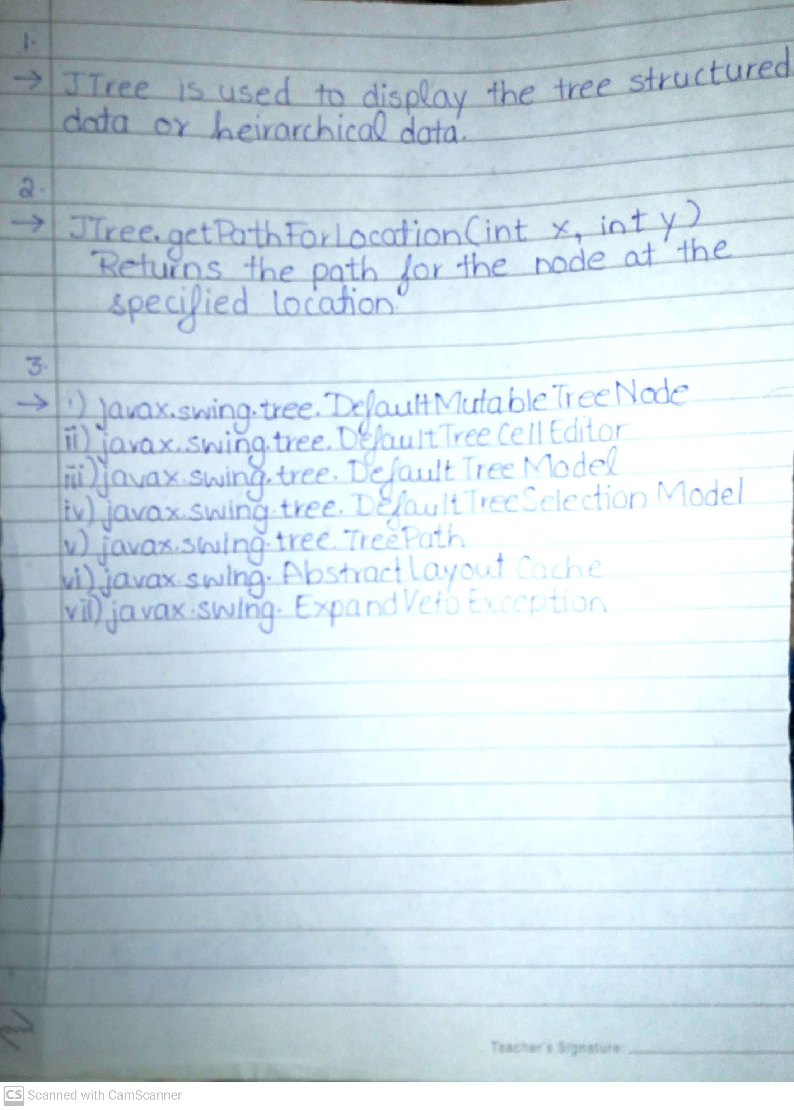

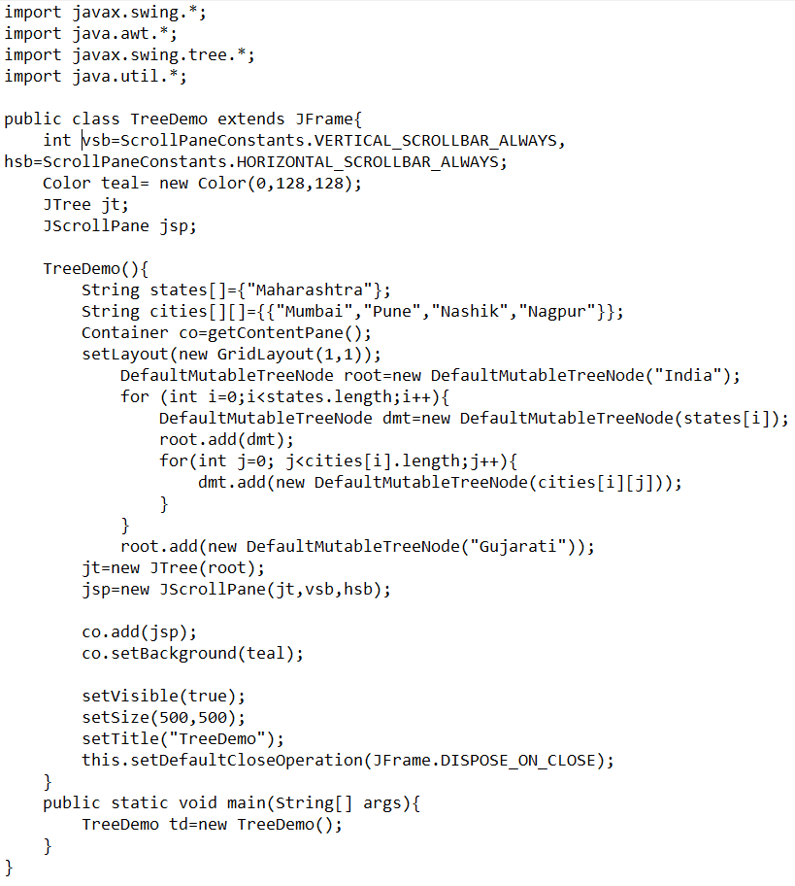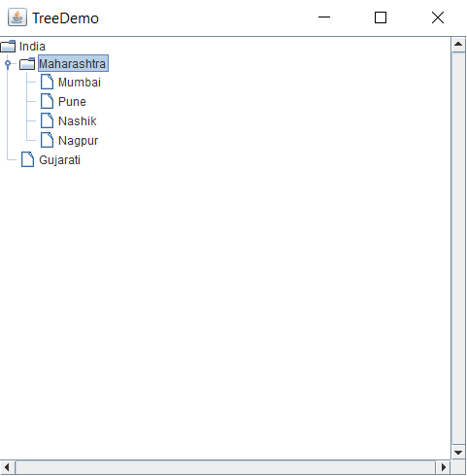

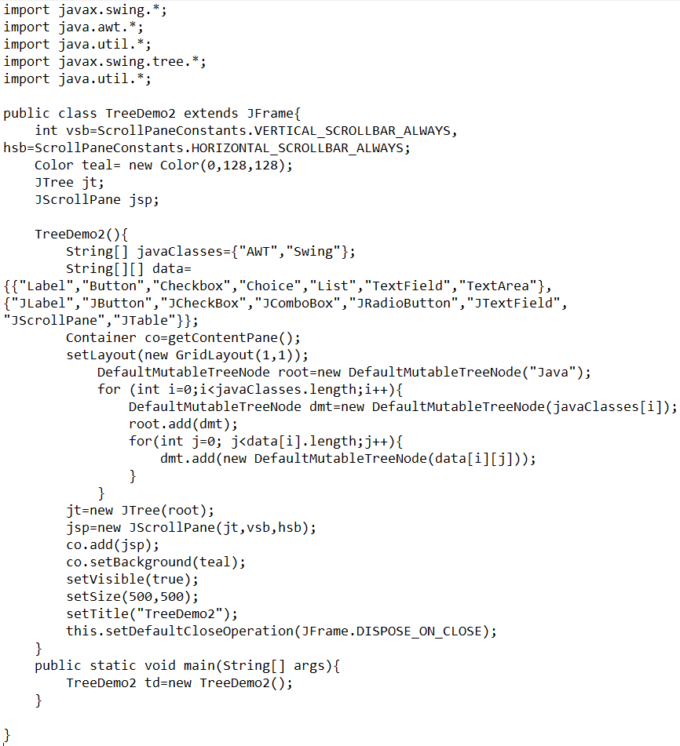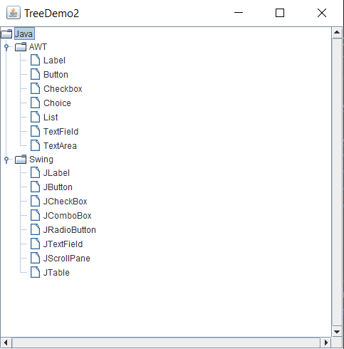

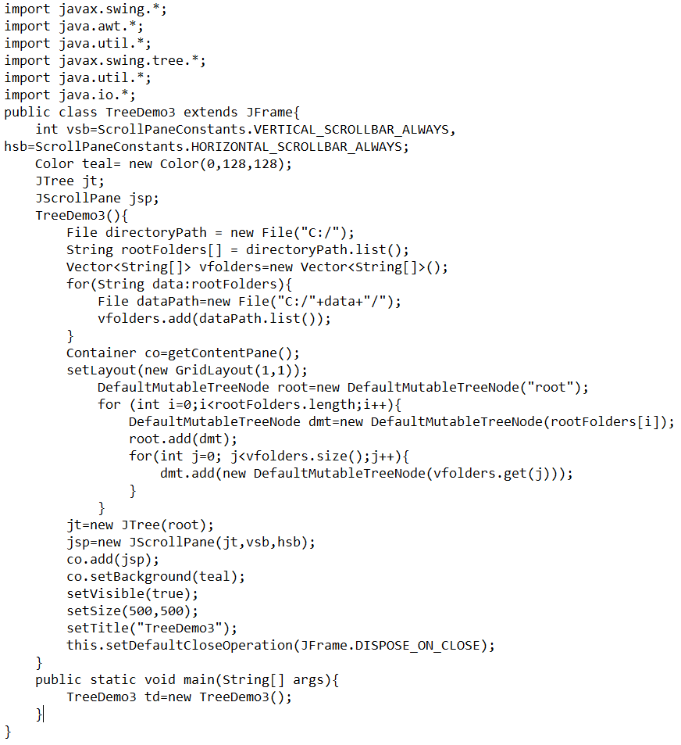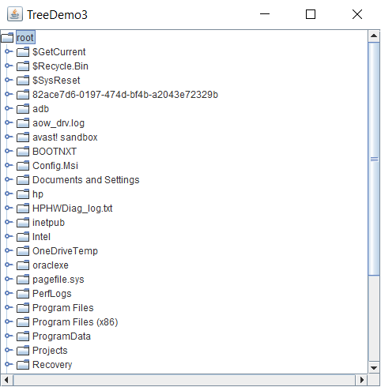

Experiment 8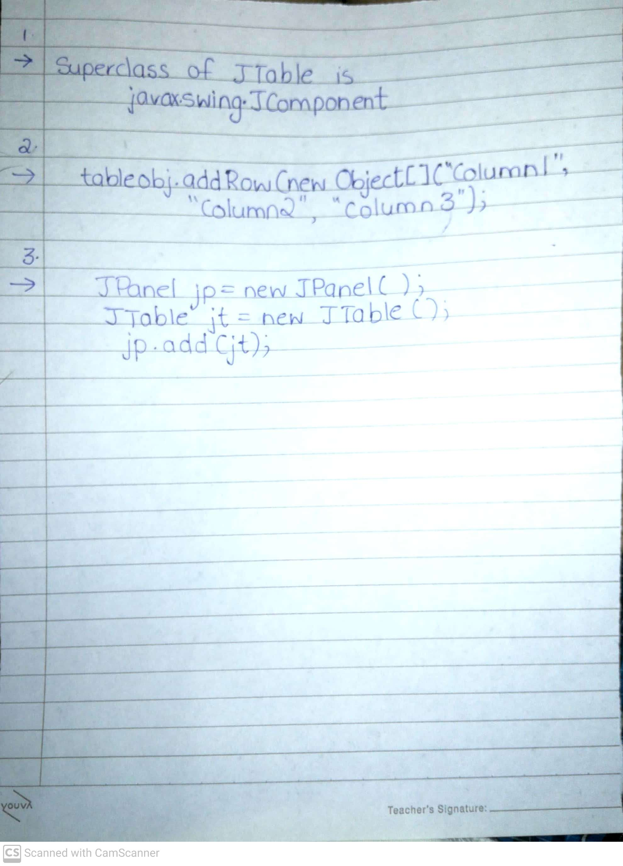

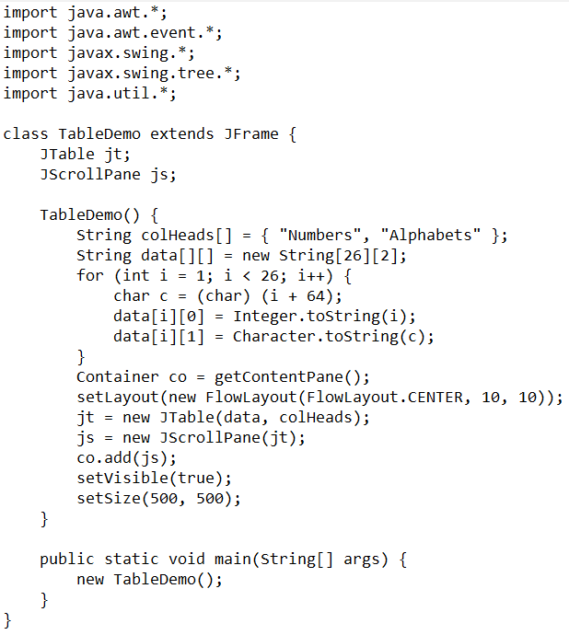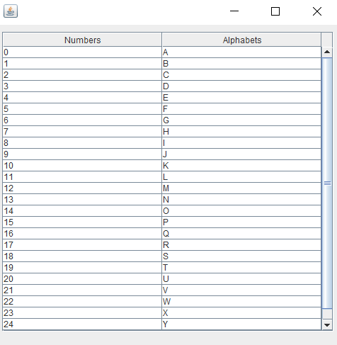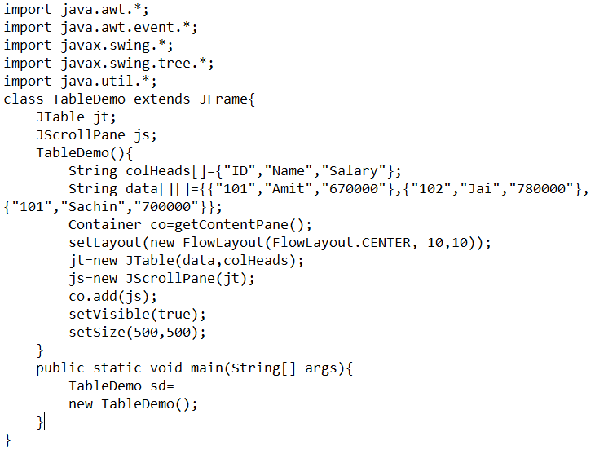 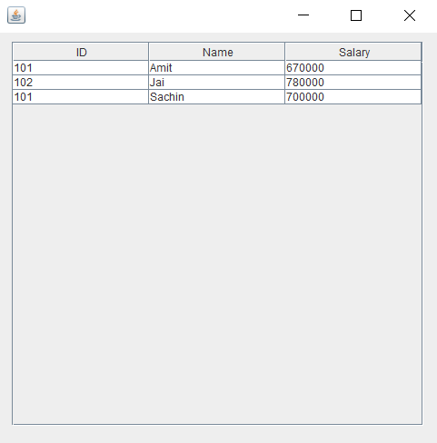

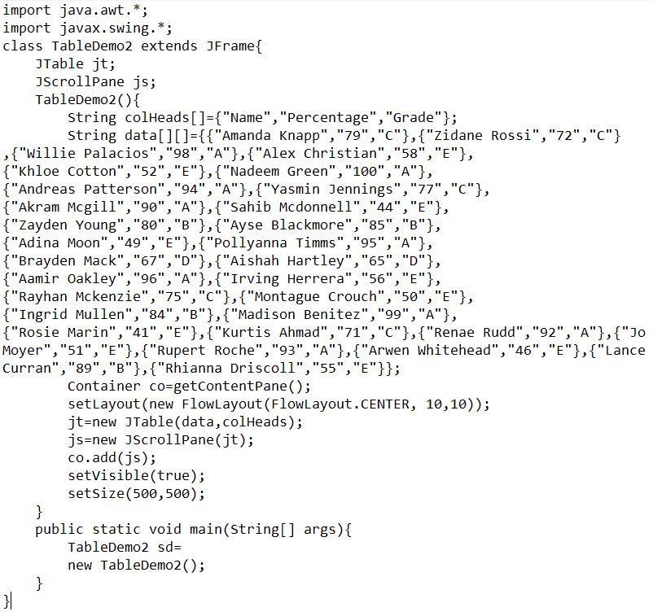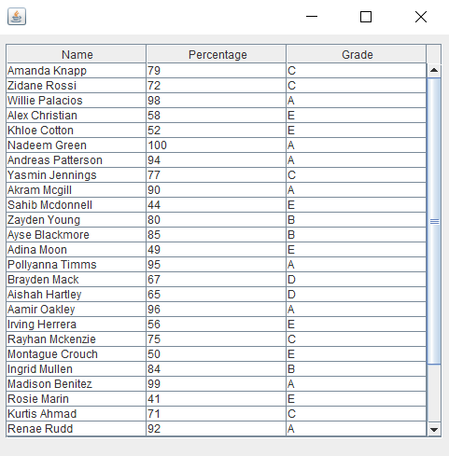

Experiment 9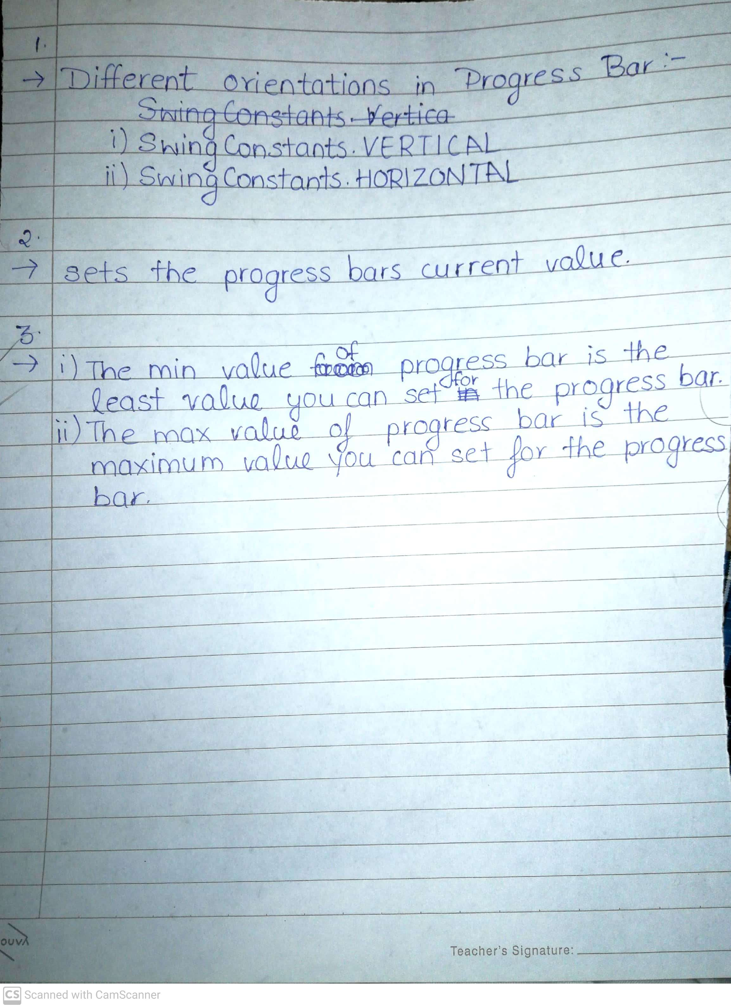

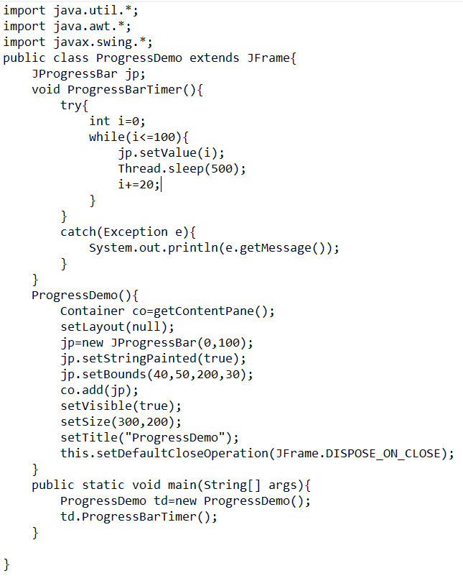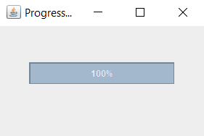

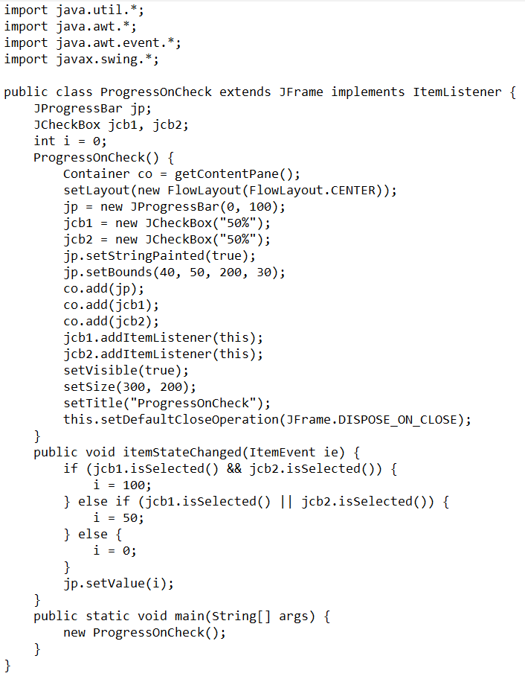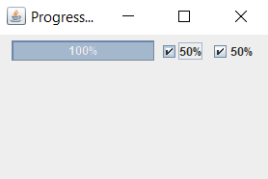

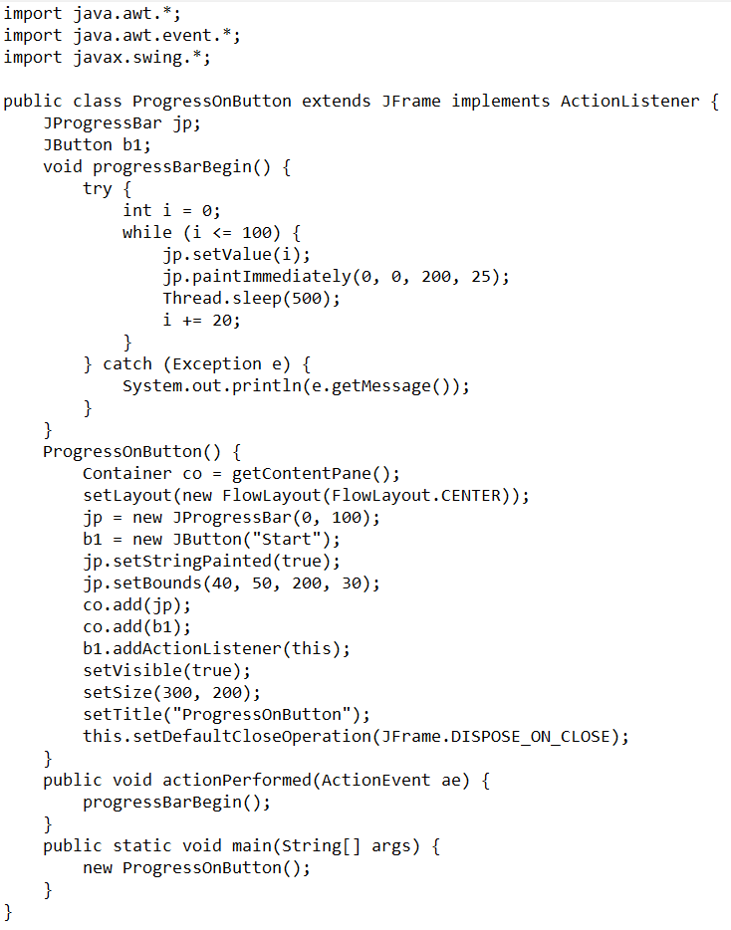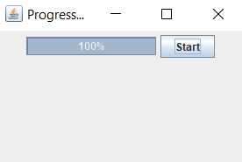

Experiment 10

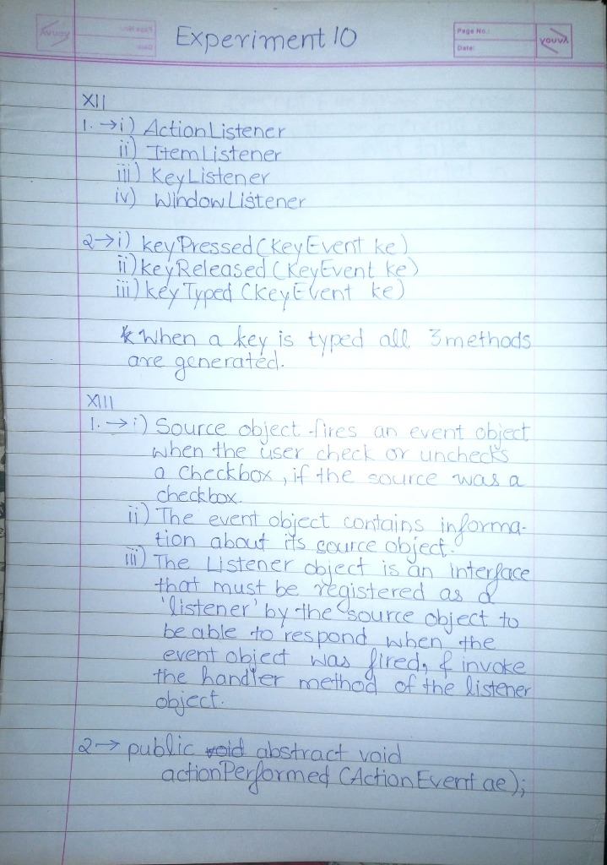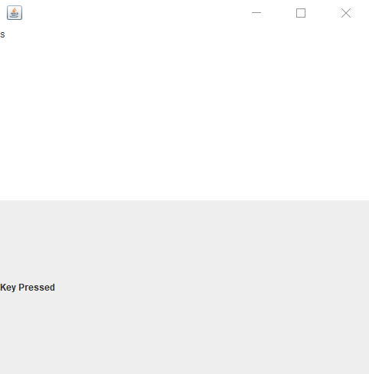

­­­import javax.swing.*;

import java.awt.*;

import java.awt.event.*;

public class KeyEventDemo0 extends JFrame implements KeyListener {

JLabel label;

KeyEventDemo0() {

Container co = getContentPane();

label = new JLabel();

JTextArea ta = new JTextArea();

co.add(ta);

co.add(label);

ta.addKeyListener(this);

setSize(500, 500);

setLayout(new GridLayout(2, 1));

setVisible(true);

}

public void keyPressed(KeyEvent e) {

label.setText("Key Pressed");

}

public void keyReleased(KeyEvent e) {

}

public void keyTyped(KeyEvent e) {

}

public static void main(String[] args) {

new KeyEventDemo0();

}

}

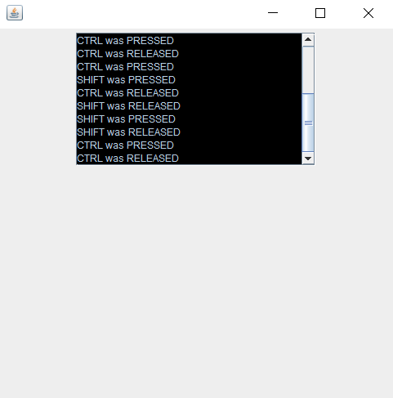

import javax.swing.*;

import java.awt.*;

import java.awt.event.*;

public class KeyEventDemo1 extends JFrame implements KeyListener {

int vsb = JScrollPane.VERTICAL_SCROLLBAR_ALWAYS;

int hsb = JScrollPane.HORIZONTAL_SCROLLBAR_NEVER;

Container co;

JTextArea ta;

KeyEventDemo1() {

co = getContentPane();

ta = new JTextArea(10, 25);

ta.setEnabled(false);

ta.setBackground(Color.black);

JScrollPane jsp = new JScrollPane(ta, vsb, hsb);

addKeyListener(this);

co.add(jsp);

setSize(500, 500);

setLayout(new FlowLayout(FlowLayout.CENTER));

setVisible(true);

}

public void keyReleased(KeyEvent ke) {

String c;

int k = ke.getKeyCode();

switch (k) {

case KeyEvent.VK_ALT: c = "ALT"; break;

case KeyEvent.VK_CONTROL: c = "CTRL";break;

case KeyEvent.VK_SHIFT: c = "SHIFT"; break;

default: c = "" + ke.getKeyChar(); break;

}

String str = ta.getText() + "\n" + c + " was RELEASED";

ta.setText(str);

}

public void keyPressed(KeyEvent ke) {

String c;

int k = ke.getKeyCode();

switch (k) {

case KeyEvent.VK_ALT: c = "ALT"; break;

case KeyEvent.VK_CONTROL: c = "CTRL"; break;

case KeyEvent.VK_SHIFT: c = "SHIFT"; break;

default: c = "" + ke.getKeyChar(); break;

}

String str = ta.getText() + "\n" + c + " was PRESSED";

ta.setText(str);

}

public void keyTyped(KeyEvent ke) {

String c;

int k = ke.getKeyCode();

switch (k) {

case KeyEvent.VK_ALT: c = "ALT"; break;

case KeyEvent.VK_CONTROL: c = "CTRL"; break;

case KeyEvent.VK_SHIFT: c = "SHIFT"; break;

default: c = "" + ke.getKeyChar(); break;

}

String str = ta.getText() + "\n" + c + " was TYPED";

ta.setText(str);

}

public static void main(String[] args) {

new KeyEventDemo1();

}

}

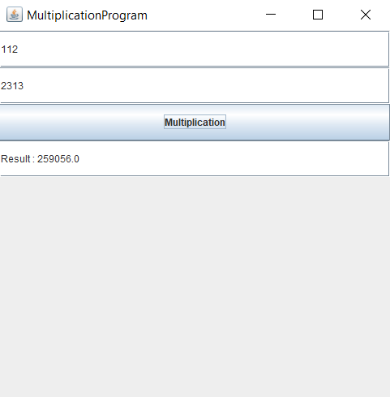

import javax.swing.*;

import java.awt.*;

import java.awt.event.*;

public class MultiplicationProgram extends JFrame implements ActionListener {

Container co;

JTextField jtf1, jtf2, jtf3;

JButton b1, b2;

MultiplicationProgram() {

co = getContentPane();

b1 = new JButton("Multiplication");

jtf1 = new JTextField();

jtf2 = new JTextField();

jtf3 = new JTextField();

co.add(jtf1);

co.add(jtf2);

co.add(b1);

co.add(jtf3);

b1.addActionListener(this);

setLayout(new GridLayout(10, 2));

setTitle("MultiplicationProgram");

setSize(500, 500);

setVisible(true);

}

public void actionPerformed(ActionEvent ae) {

float a = Float.parseFloat(jtf1.getText());

float b = Float.parseFloat(jtf2.getText());

jtf3.setText("Result : " + Float.toString((a * b)));

}

public static void main(String[] args) {

new MultiplicationProgram();

}

}

Experiment 11

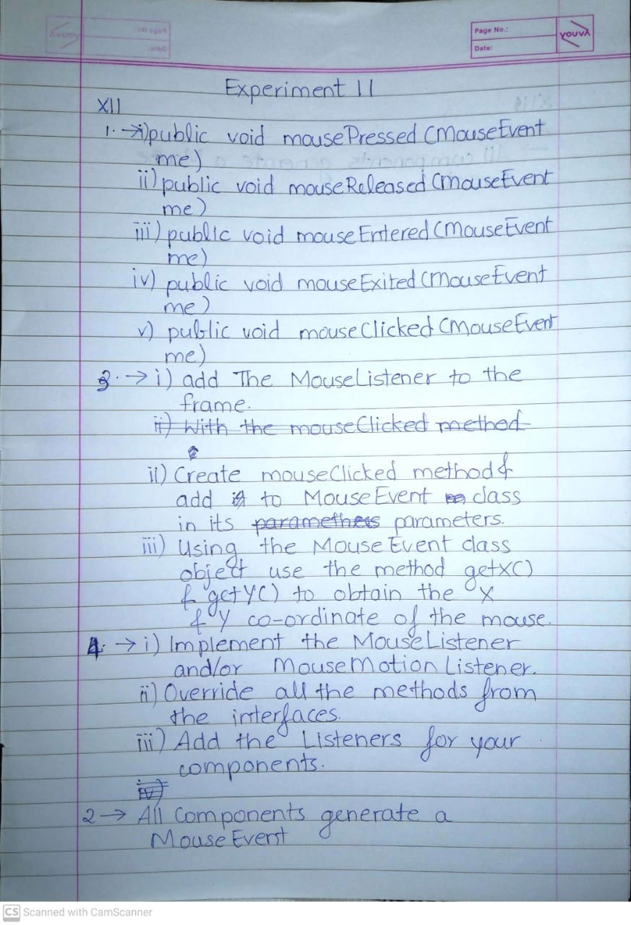

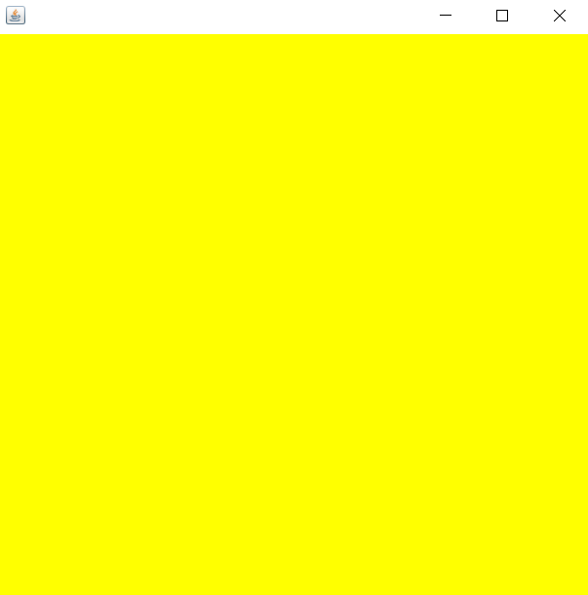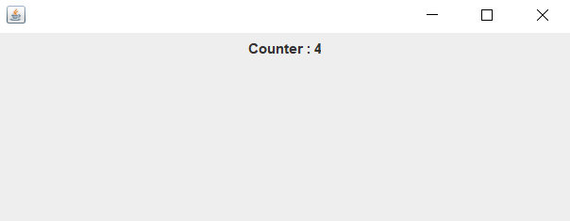

import javax.swing.*;

import java.awt.*;

import java.awt.event.*;

public class MouseDemo extends JFrame implements MouseListener

{

Container co;

MouseDemo()

{

co = getContentPane();

co.addMouseListener(this);

setVisible(true);

setSize(500,500);

}

public void mousePressed(MouseEvent e)

{

co.setBackground(Color.red);

}

public void mouseReleased(MouseEvent e)

{

co.setBackground(Color.blue);

}

public void mouseEntered(MouseEvent e)

{

co.setBackground(Color.yellow);

}

public void mouseExited(MouseEvent e)

{

co.setBackground(Color.black);

}

public void mouseClicked(MouseEvent e)

{

co.setBackground(Color.green);

}

public static void main(String[] args) {

new MouseDemo();

}

}

import javax.swing.*;

import java.awt.*;

import java.awt.event.*;

public class MouseDemo1 extends JFrame implements MouseListener

{

    Container  co;

    int counter = 0;

    JLabel label;

    MouseDemo1() {

        co = getContentPane();

        label = new JLabel("Counter : "  + counter);

        co.add(label);

        co.addMouseListener(this);

        co.setLayout(new FlowLayout(FlowLayout.CENTER));

        setVisible(true);

        setSize(500,200);

    }

    public void mousePressed(MouseEvent e) {

    }

    public void mouseReleased(MouseEvent e) {

    }

    public void mouseEntered(MouseEvent e) {

    }

    public void mouseExited(MouseEvent e) {

    }

    public void mouseClicked(MouseEvent e) {

        counter++;

        label.setText("Counter : " + counter);

    }

    public static void main(String[] args) {

        new MouseDemo1();

    }

}

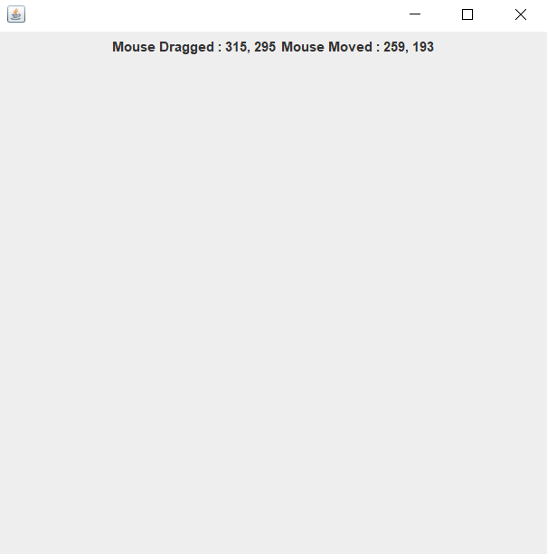

import javax.swing.*;

import java.awt.*;

import java.awt.event.*;

public class MouseDemo2 extends JFrame implements MouseMotionListener

{

    Container  co;

    JLabel l1;

    JLabel l2;

    MouseDemo2() {

        co = getContentPane();

        l1 = new JLabel("Mouse Moved : None");

        l2 = new JLabel("Mouse Dragged : None");

        co.add(l1);

        co.add(l2);

        co.addMouseMotionListener(this);

        setLayout(new FlowLayout(FlowLayout.CENTER));

        setVisible(true);

        setSize(500,500);

    }

    public void mouseDragged(MouseEvent e) {

        l1.setText("Mouse Dragged : " + e.getX() + ", " + e.getY());

    }

    public void mouseMoved(MouseEvent e) {

        l2.setText("Mouse Moved : " + e.getX() + ", " + e.getY());

    }

    public static void main(String[] args) {

        new MouseDemo2();

    }

}

Experiment 12

# Theory

1. Used to set a character that would appear whenever a user will type the text
2. The purpose of a JPasswordField class is a text portion/part specialised for password entry. It permits the editing of a single line of text. It is a sub-class JTextField class.
3. JTextArea can be used to accept multiline inputs from the user

# Practical

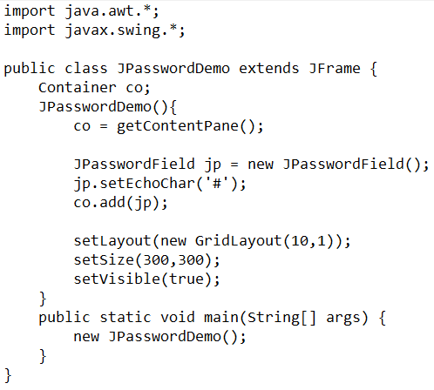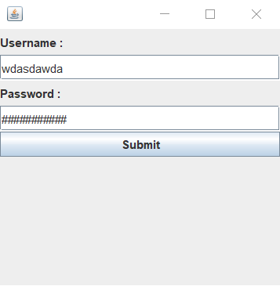

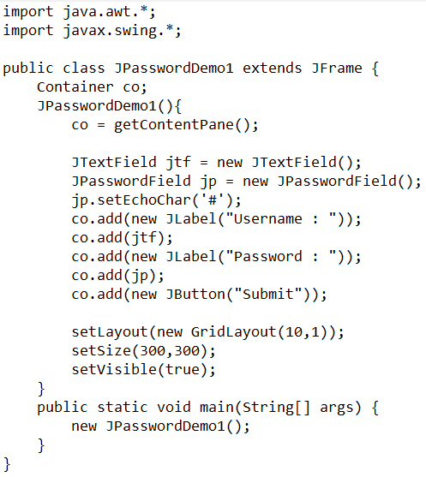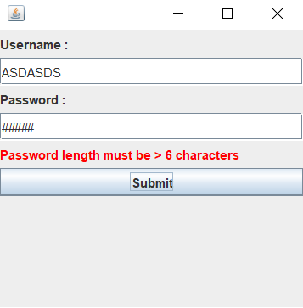

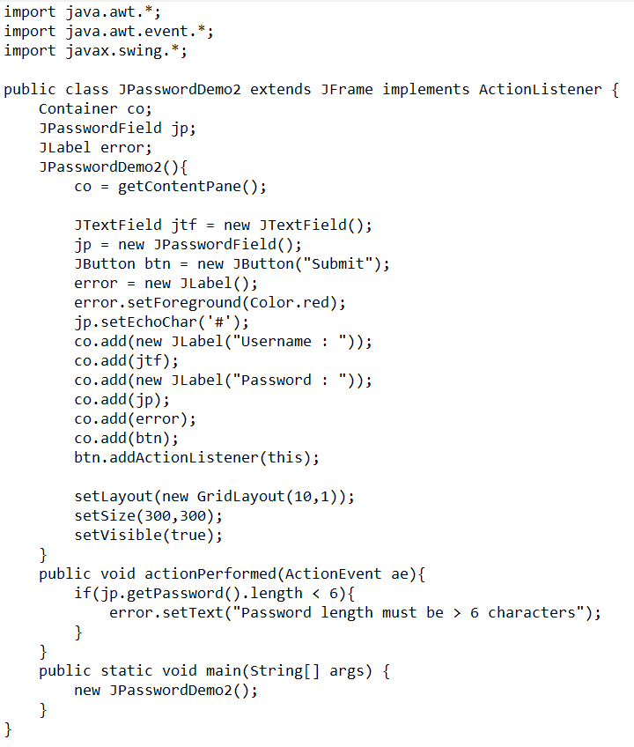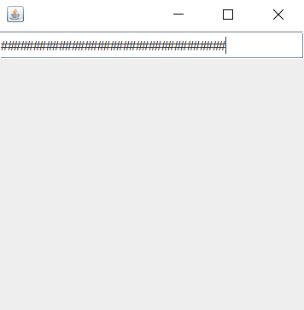

Experiment 14

# Theory



|  |  |
| --- | --- |
| IPV4 | IPV6 |
| * 32-bit address space | 128-bit address space |
| * Address representation in Decimal | Address representation in Hexadecimal |
| * No packet flow indication | Uses flow label for packet flow indication |
| * Can use broadcasting | Cannot use broadcasting it instead uses multicasting or anycasting. |

1. getByName() : Determines the IP address of a host from the given host's name.  
   getAllByName() : Returns an array of IP addresses, based on the given host name and the configured name service on the system.
2. The steps are:-
   1. Go in Settings
   2. Click on Network and Internet
   3. Click on Change adapter options
   4. Right Click on your current network adapter and choose Properties
   5. Select Internet Protocol Version 4 and click on Properties
   6. Once you get the pop-up window, select “Enter the IP address you want” and fil the IP Address, For Subnet Mask, and Default Gateway Address. Next, click on OK to save changes.

# Programs

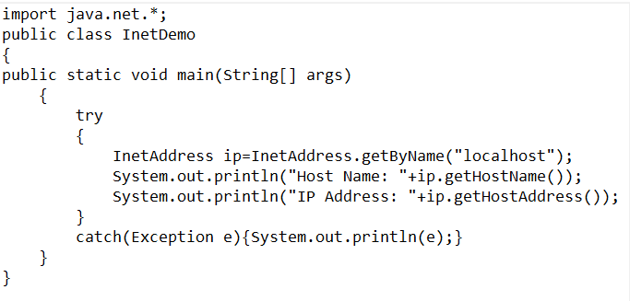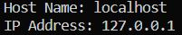

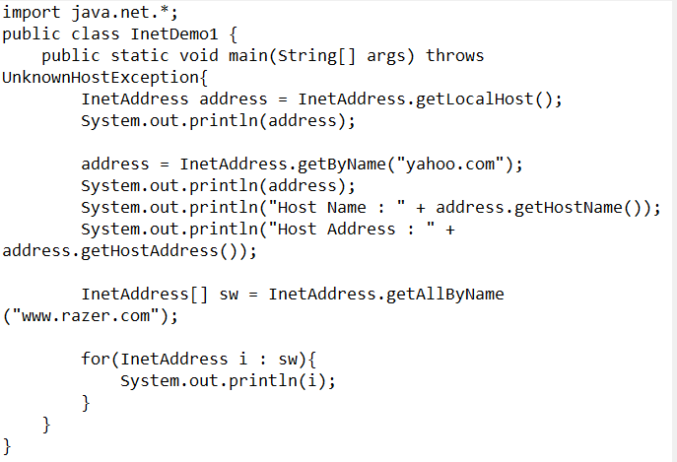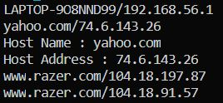

Experiment 15

# Theory

1. The openConnection() method of URL class opens the connection to specified URL and URLConnection instance that represents a connection to the remote object referred by the URL.
2. MalformedURLException
3. java.net

# Programs

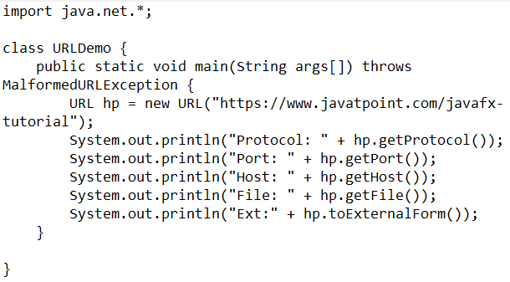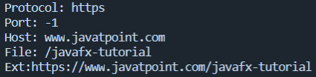

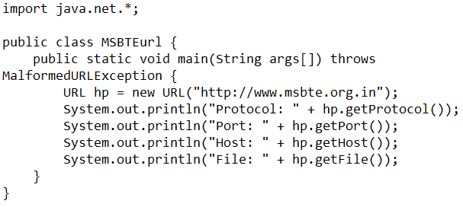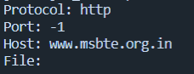

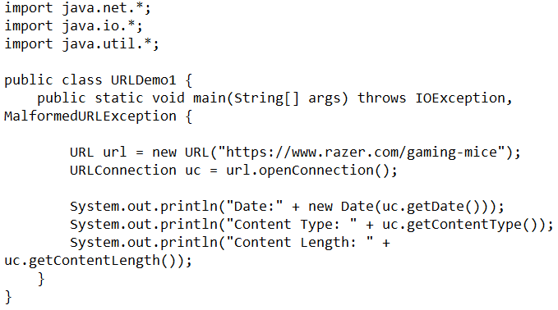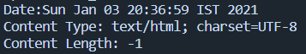

Experiment 18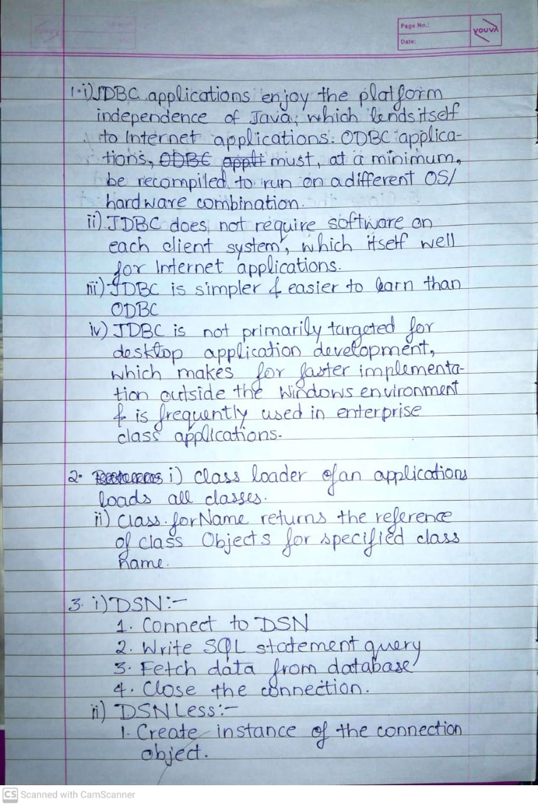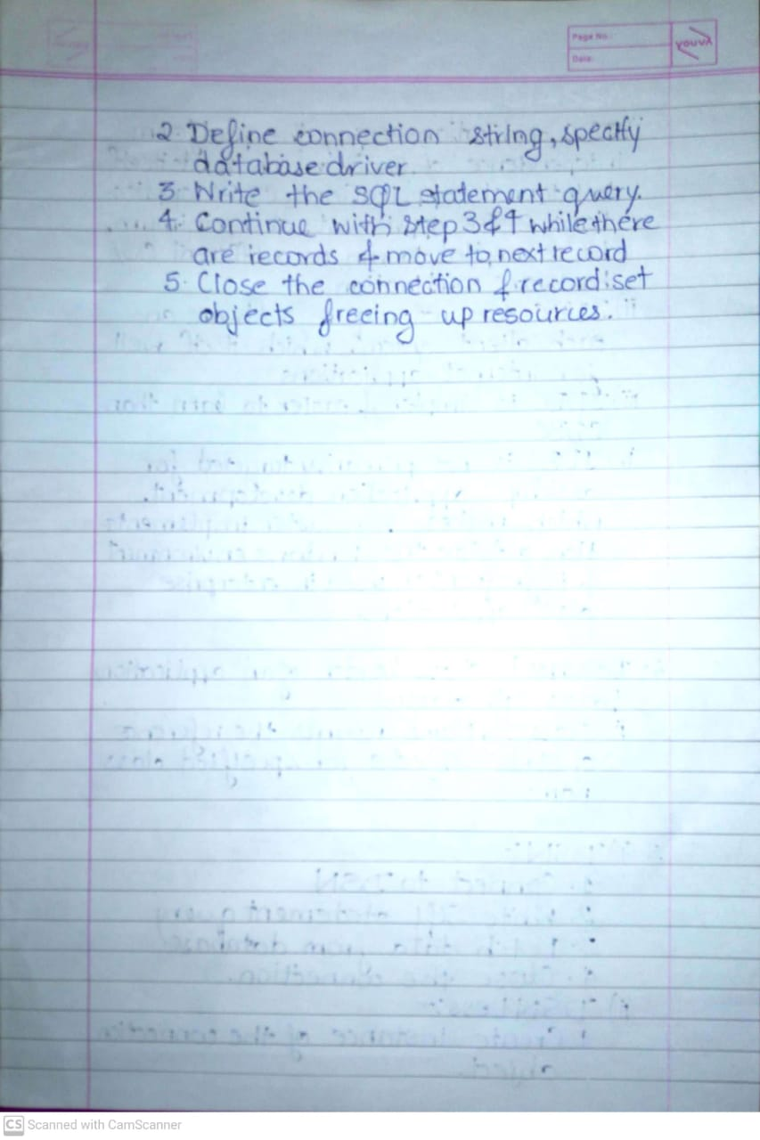

import java.sql.*;

class Exp18a {

public String database = "C:\\Users\\deong\\College\\Java\\Manual-Programs\\Experiment18\\SampleDatabase.accdb";

private Connection conn;

// Create Connection

public void createConnection() {

try {

conn = DriverManager.getConnection("jdbc:ucanaccess://" + database);

} catch (SQLException e) {

System.out.println("Connection Failed");

System.exit(1);

}

}

public void closeConnection() {

try {

conn.close();

} catch (SQLException e) {

System.out.println("Close Connection Failed ?");

}

}

public void updateQuery(String query) {

try {

Statement statement = conn.createStatement();

statement.executeUpdate(query);

} catch (SQLException e) {

System.out.println("Error in updateQuery()");

}

}

public static void main(String[] args) {

Exp18a dbconn = new Exp18a();

try {

Class.forName("net.ucanaccess.jdbc.UcanaccessDriver");

} catch (Exception e) {

System.out.println("Error in Loading Driver");

}

dbconn.createConnection();

// dbconn.updateQuery("DROP TABLE Student;");

dbconn.updateQuery("CREATE TABLE Student (rollno COUNTER PRIMARY KEY, name TEXT(50));");

dbconn.updateQuery("INSERT INTO Student (name) VALUES( 'Deon')");

dbconn.updateQuery("INSERT INTO Student (name) VALUES( 'Agares')");

}

}

import java.sql.*;

public class Exp18b {

public String database = "C:\\Users\\deong\\College\\Java\\Manual-Programs\\Experiment18\\SampleDatabase.accdb";

private Connection conn;

// Create Connection

public void createConnection() {

try {

conn = DriverManager.getConnection("jdbc:ucanaccess://" + database);

} catch (SQLException e) {

System.out.println("Connection Failed");

System.exit(1);

}

}

public void closeConnection() {

try {

conn.close();

} catch (SQLException e) {

System.out.println("Close Connection Failed ?");

}

}

public void query() throws SQLException {

Statement st = conn.createStatement();

String str = "select * from student";

ResultSet rs = st.executeQuery(str);

String text = " ";

System.out.println("Roll Number \t Name");

while (rs.next()) {

text = text + rs.getInt(1) + "\t" + rs.getString(2) + "\n";

}

System.out.print(text);

}

public static void main(String[] args) throws SQLException {

Exp18b dbconn = new Exp18b();

try {

Class.forName("net.ucanaccess.jdbc.UcanaccessDriver");

} catch (Exception e) {

System.out.println("Error in Loading Driver");

}

dbconn.createConnection();

System.out.println("Connection to the database created");

dbconn.query();

}

}

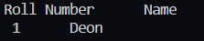

import java.sql.*;

class Exp18c {

public String database = "C:\\Users\\deong\\College\\Java\\Manual-Programs\\Experiment18\\SampleDatabase.accdb";

private Connection conn;

// Create Connection

public void createConnection() {

try {

conn = DriverManager.getConnection("jdbc:ucanaccess://" + database);

} catch (SQLException e) {

System.out.println("Connection Failed");

System.exit(1);

}

}

public void closeConnection() {

try {

conn.close();

} catch (SQLException e) {

System.out.println("Close Connection Failed ?");

}

}

public void updateQuery(String query) {

try {

Statement statement = conn.createStatement();

statement.executeUpdate(query);

} catch (SQLException e) {

System.out.println("Error in updateQuery()");

}

}

public static void main(String[] args) {

Exp18c dbconn = new Exp18c();

try {

Class.forName("net.ucanaccess.jdbc.UcanaccessDriver");

} catch (Exception e) {

System.out.println("Error in Loading Driver");

}

dbconn.createConnection();

dbconn.updateQuery("DROP TABLE Employee;");

dbconn.updateQuery("CREATE TABLE Employee (emp_id INTEGER PRIMARY KEY, emp_name VARCHAR(50));");

}

}

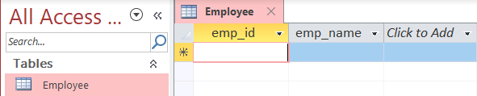

import java.sql.*;

class Exp18d {

public String database = "C:\\Users\\deong\\College\\Java\\Manual-Programs\\Experiment18\\SampleDatabase.accdb";

private Connection conn;

// Create Connection

public void createConnection() {

try {

conn = DriverManager.getConnection("jdbc:ucanaccess://" + database);

} catch (SQLException e) {

System.out.println("Connection Failed");

System.exit(1);

}

}

public void closeConnection() {

try {

conn.close();

} catch (SQLException e) {

System.out.println("Close Connection Failed ?");

}

}

public void printStudents(String where) {

try {

Statement statement = conn.createStatement();

ResultSet resultSet = statement.executeQuery("SELECT * FROM Students WHERE " + where + ";");

while (resultSet.next()) {

String employee = "Student " + resultSet.getString("ID") + ":" + "\n\tName : "

+ resultSet.getString("name") + "\n\tPercentage : " + resultSet.getString("percentage");

System.out.println(employee);

}

} catch (SQLException e) {

System.out.println("Error in Printing Employees With WHERE Condition");

}

}

public static void main(String[] args) {

Exp18d dbconn = new Exp18d();

try {

Class.forName("net.ucanaccess.jdbc.UcanaccessDriver");

} catch (Exception e) {

System.out.println("Error in Loading Driver");

}

dbconn.createConnection();

dbconn.printStudents("percentage > 70");

}

}

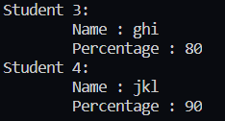

Experiment 19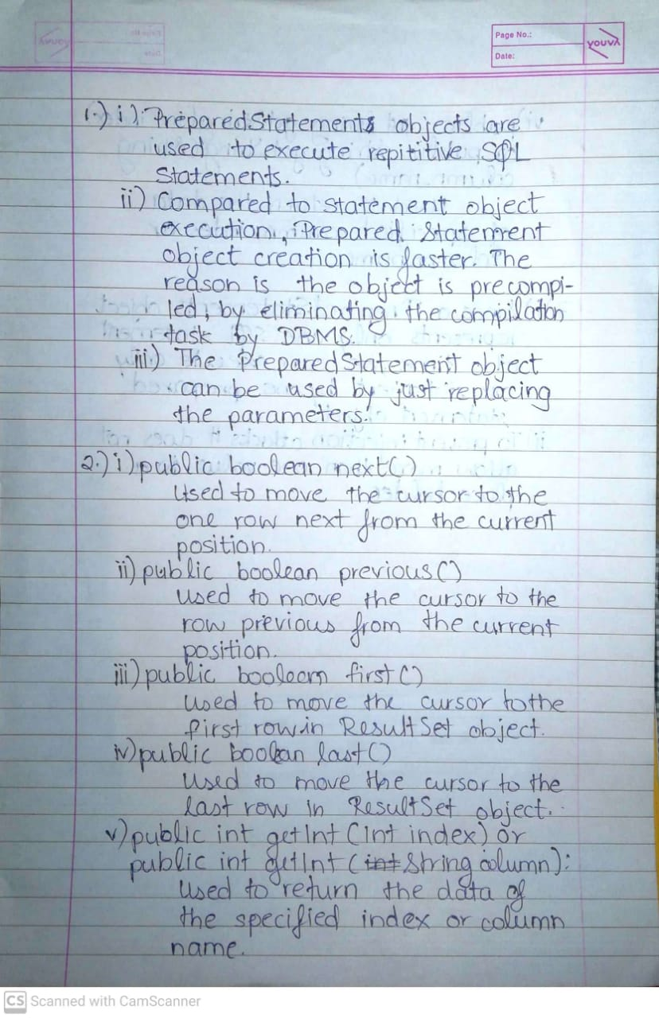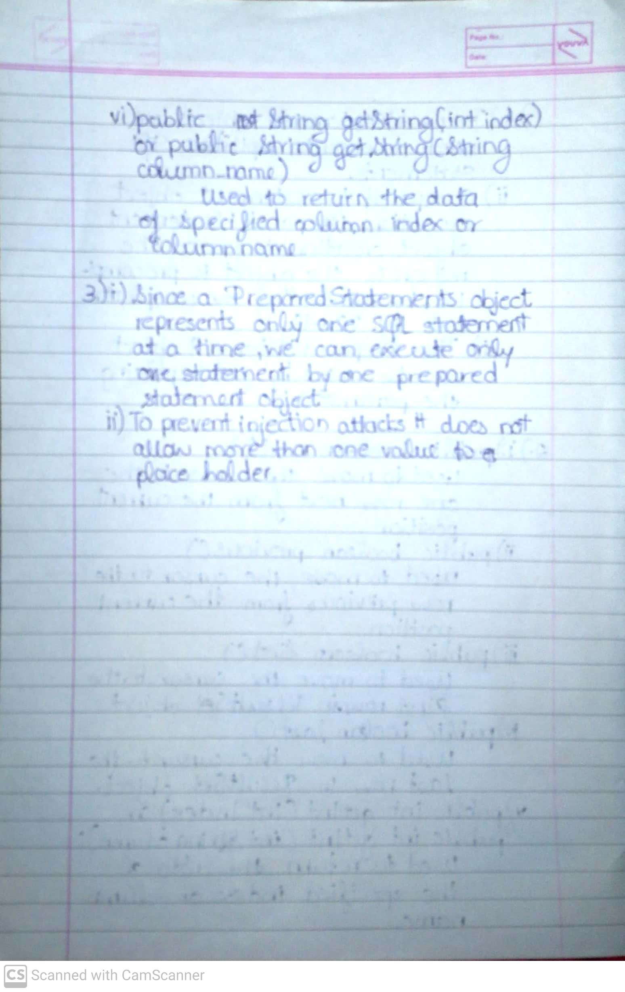

import java.sql.*;

class Exp19a {

public String database = "C:\\Users\\deong\\College\\Java\\Manual-Programs\\Experiment19\\MSBTE.accdb";

private Connection conn;

// Create Connection

public void createConnection() {

try {

conn = DriverManager.getConnection("jdbc:ucanaccess://" + database);

} catch (SQLException e) {

System.out.println("Connection Failed");

System.exit(1);

}

}

public void closeConnection() {

try {

conn.close();

} catch (SQLException e) {

System.out.println("Close Connection Failed ?");

}

}

public void updateQuery(String query) {

try {

Statement statement = conn.createStatement();

statement.executeUpdate(query);

} catch (SQLException e) {

System.out.println("Error in updateQuery()");

}

}

public static void main(String[] args) {

Exp19a dbconn = new Exp19a();

try {

Class.forName("net.ucanaccess.jdbc.UcanaccessDriver");

} catch (Exception e) {

System.out.println("Error in Loading Driver");

}

dbconn.createConnection();

dbconn.updateQuery("UPDATE Students SET FirstName = 'Deon' , LastName = 'Gracias' WHERE ID = 3;");

}

}

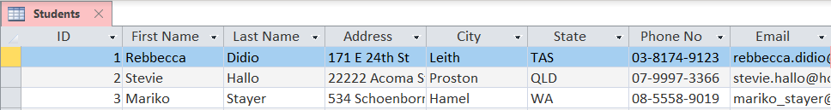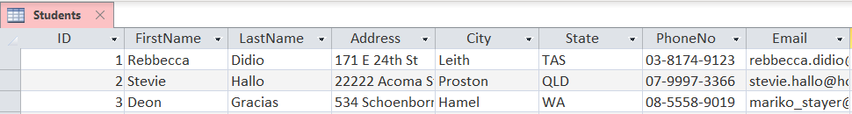

import java.sql.*;

class Exp19b {

public String database = "C:\\Users\\deong\\College\\Java\\Manual-Programs\\Experiment19\\SampleDatabase.accdb";

private Connection conn;

// Create Connection

public void createConnection() {

try {

conn = DriverManager.getConnection("jdbc:ucanaccess://" + database);

} catch (SQLException e) {

System.out.println("Connection Failed");

System.exit(1);

}

}

public void closeConnection() {

try {

conn.close();

} catch (SQLException e) {

System.out.println("Close Connection Failed ?");

}

}

public void updateQuery(int id, String firstName, String lastName) {

try {

PreparedStatement stmt = conn.prepareStatement("insert into student values(?,?,?)");

stmt.setInt(1, id);

stmt.setString(2, firstName);

stmt.setString(3, lastName);

int i = stmt.executeUpdate();

System.out.println(i + " records inserted");

} catch (SQLException e) {

System.out.println("Error in updateQuery()");

}

}

public static void main(String[] args) {

Exp19b dbconn = new Exp19b();

try {

Class.forName("net.ucanaccess.jdbc.UcanaccessDriver");

} catch (Exception e) {

System.out.println("Error in Loading Driver");

}

dbconn.createConnection();

dbconn.updateQuery(101, "Abhishek", "Yadav");

}

}



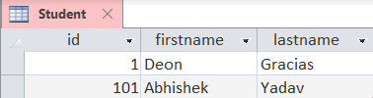

import java.sql.*;

public class Exp19c {

public String database = "C:\\Users\\deong\\College\\Java\\Manual-Programs\\Experiment19\\MSBTE.accdb";

private Connection conn;

// Create Connection

public void createConnection() {

try {

conn = DriverManager.getConnection("jdbc:ucanaccess://" + database);

} catch (SQLException e) {

System.out.println("Connection Failed");

System.exit(1);

}

}

public void closeConnection() {

try {

conn.close();

} catch (SQLException e) {

System.out.println("Close Connection Failed ?");

}

}

public void selectQuery() {

try {

Statement stmt = conn.createStatement();

ResultSet rs = stmt.executeQuery("SELECT ID, first_name, last_name FROM Student;");

System.out.println("--------------------------------------");

System.out.printf("%5s | %13s | %13s\n", "ID", "FirstName", "LastName");

System.out.println("--------------------------------------");

while (rs.next()) {

System.out.printf("%5s | %13s |%13s\n", Integer.toString(rs.getInt("ID")), rs.getString("first_name"),

rs.getString("last_name"));

}

} catch (SQLException e) {

e.printStackTrace();

System.out.println("Error in selectQuery()");

}

}

public static void main(String[] args) {

Exp19c dbconn = new Exp19c();

try {

Class.forName("net.ucanaccess.jdbc.UcanaccessDriver");

} catch (Exception e) {

System.out.println("Error in Loading Driver");

}

dbconn.createConnection();

dbconn.selectQuery();

}

}

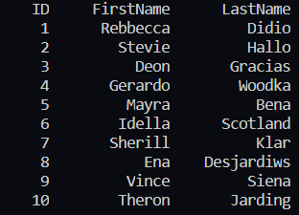

Experiment 20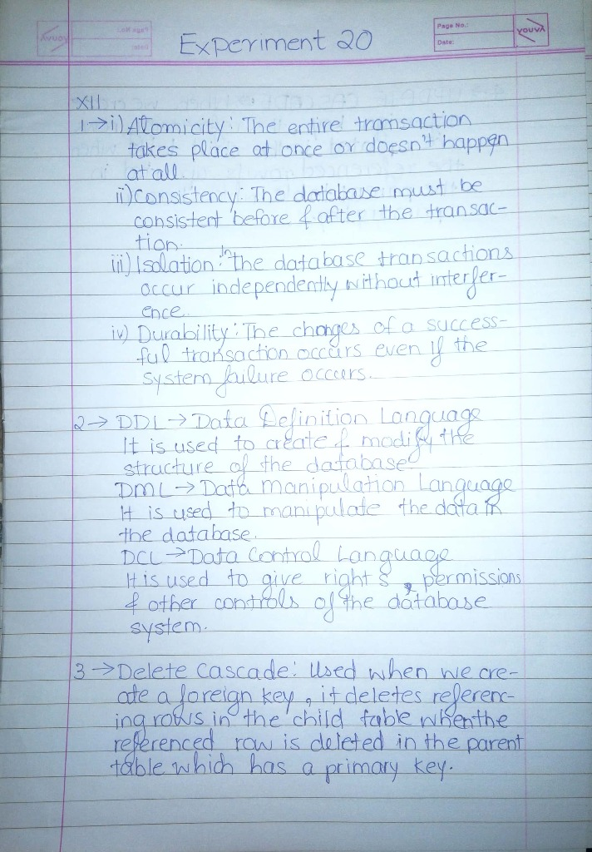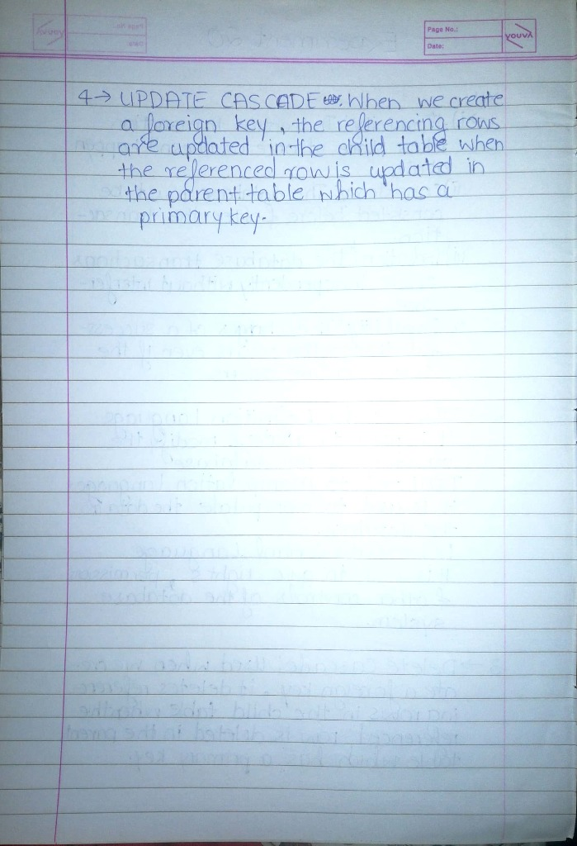

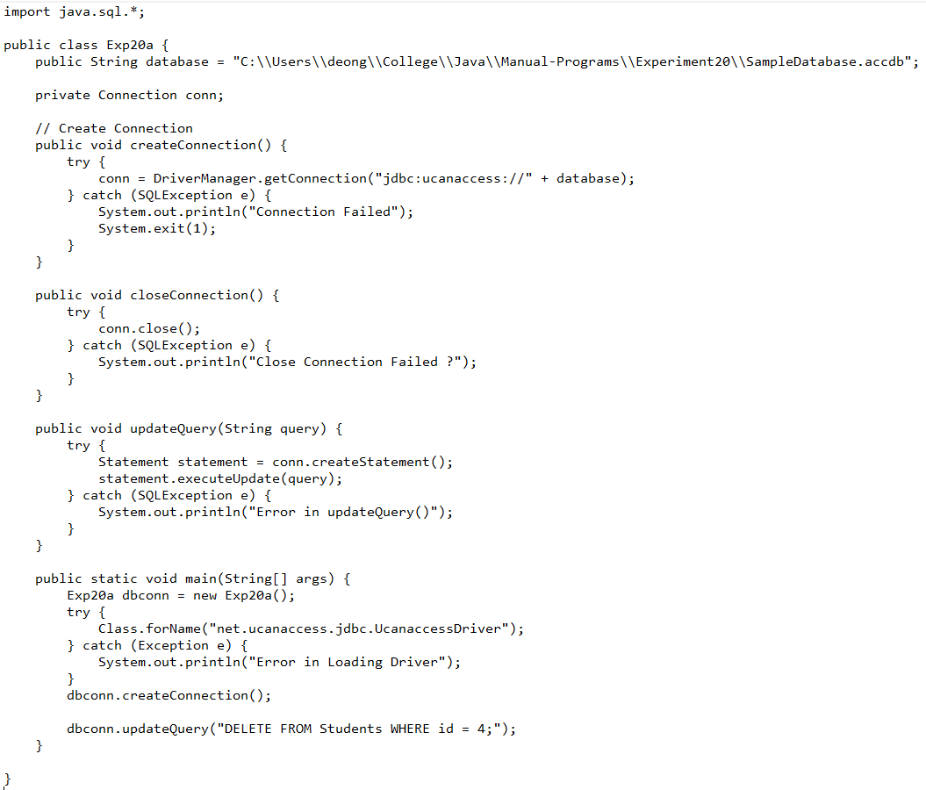

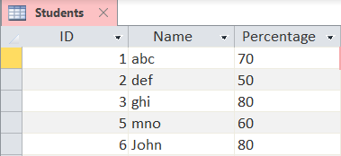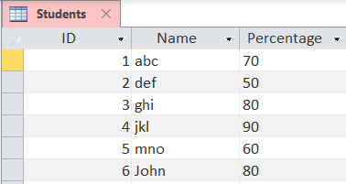

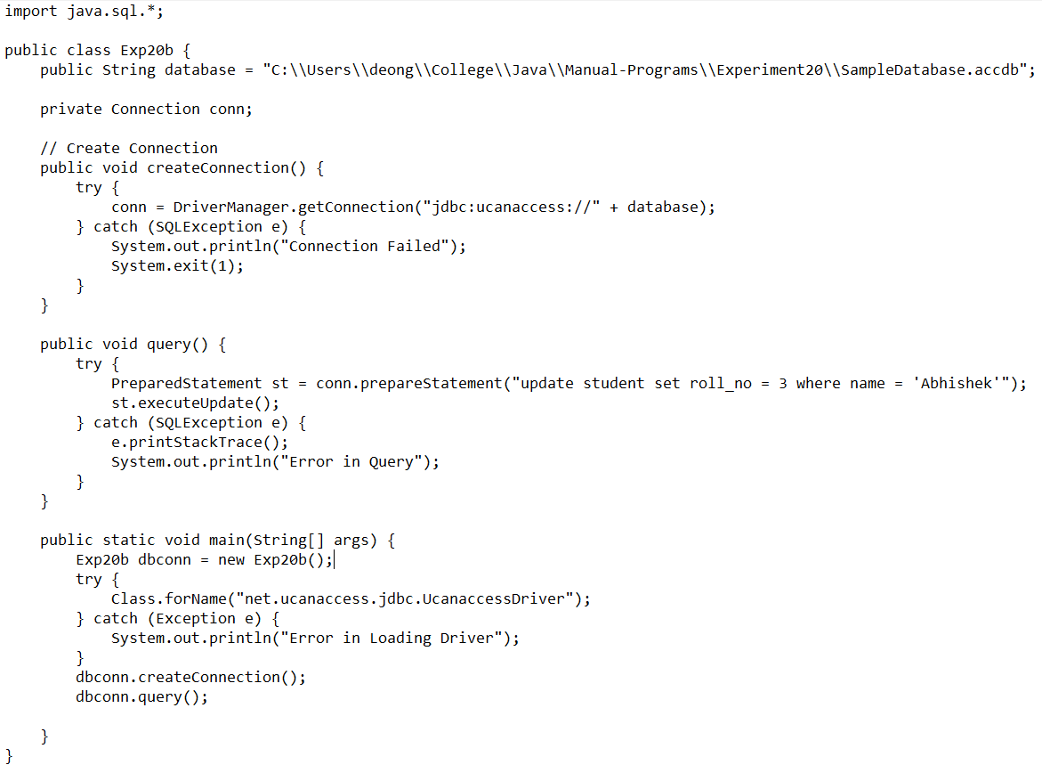

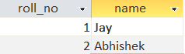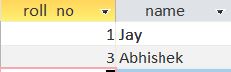

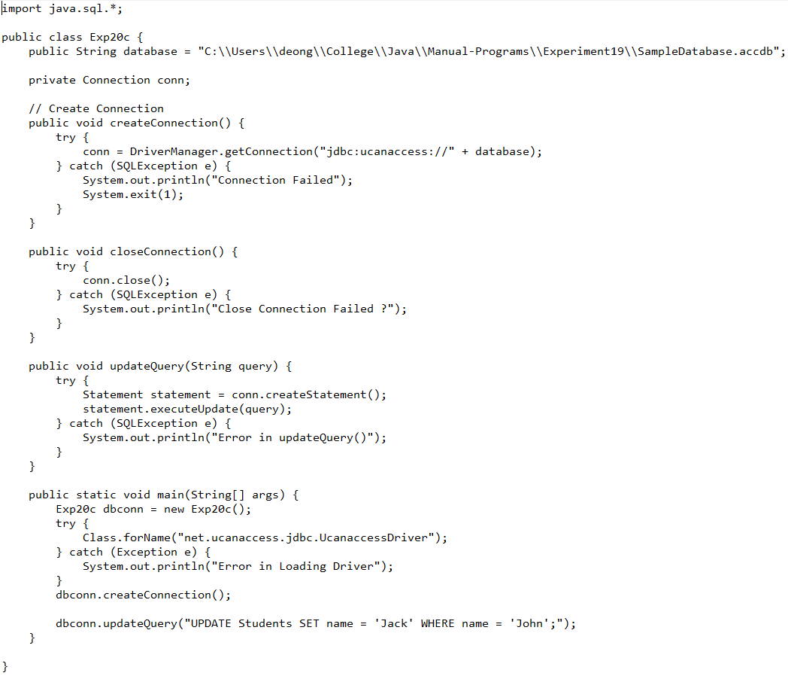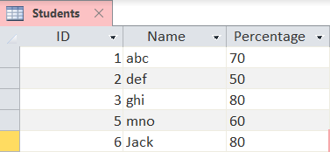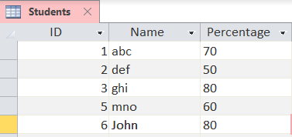

import java.sql.Connection;

import java.sql.DriverManager;

import java.sql.Statement;

import java.sql.PreparedStatement;

import java.sql.ResultSet;

import java.sql.SQLException;

public class Exp20d {

public String database = "C:\\Users\\deong\\College\\Java\\Manual-Programs\\Experiment20\\SampleDatabase.accdb";

private Connection conn;

// Create Connection

public void createConnection() {

try {

conn = DriverManager.getConnection("jdbc:ucanaccess://" + database);

} catch (SQLException e) {

System.out.println("Connection Failed");

System.exit(1);

}

}

public void updateQuery(String query) {

try {

Statement statement = conn.createStatement();

statement.executeUpdate(query);

} catch (SQLException e) {

System.out.println("Error in updateQuery()");

}

}

public void insertQuery(String id, String name, float price) {

try {

PreparedStatement statement = conn.prepareStatement("INSERT INTO Product (ID, Name, Price) VALUES(?,?,?);");

statement.setString(1, id);

statement.setString(2, name);

statement.setFloat(3, price);

statement.executeUpdate();

} catch (SQLException e) {

System.out.println("Error in insertQuery()");

}

}

public void selectQuery(String query) {

try {

Statement statement = conn.createStatement();

ResultSet resultSet = statement.executeQuery(query);

while (resultSet.next()) {

String product = "Product " + resultSet.getString("ID") + ":" + "\n\tName : "

+ resultSet.getString("name") + "\n\tPrice : " + resultSet.getFloat("price");

System.out.println(product);

}

} catch (SQLException e) {

System.out.println("Error in Printing With WHERE Condition");

}

}

public static void main(String[] args) {

Exp20d dbconn = new Exp20d();

try {

Class.forName("net.ucanaccess.jdbc.UcanaccessDriver");

} catch (Exception e) {

System.out.println("Error in Loading Driver");

}

dbconn.createConnection();

dbconn.updateQuery("DROP TABLE Product;");

dbconn.updateQuery("CREATE TABLE Product (ID VARCHAR(10), name VARCHAR(50), price FLOAT);");

dbconn.insertQuery("P1234", "abc", 300);

dbconn.insertQuery("P1234", "abc", 900);

dbconn.insertQuery("P1234", "abc", 700);

dbconn.selectQuery("SELECT ID , name , price FROM Product WHERE price > 500 AND ID = 'P1234';");

}

}

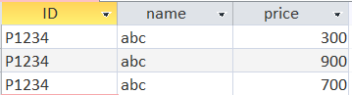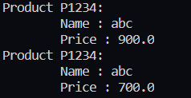

Experiment 22

# Theory

1. Types of Servlets
   1. Generic servlets
      1. Extend javax.servlet.GenericServlet.
      2. Are protocol independent. They contain no inherent HTTP support or any other transport protocol.
      3. The default port for the Apache Tomcat service is 8080. This port is defined for HTML traffic along with the more often used port 80.
   2. HTTP servlets
      1. Extend javax.servlet.HttpServlet.
      2. Have built-in HTTP protocol support and are more useful in a Sun Java System Web Server environment.
      3. The GlassFish Server port number: The default is 8080. The administration server's port number: The default is 4848. An administration user name and password: The default user name is admin , and by default no password is required.
2. Difference Between doGet() and doPost()
   1. doGet() :-
      1. Parameters are appended to the URL, and sent along with the header information. So it brings up a security issues (eg. Password).
      2. We can send maximum size of data 240 bytes.
      3. Parameters are not encrypted.
      4. Processing is Faster
      5. Bookmark is possible
   2. doPost() :-
      1. Parameters are sent through Request body.
      2. We can send a large amount of data.
      3. Parameters are encrypted.
      4. Processing is Slower
      5. Bookmark is not possible.
3. Explain ServletConfig and ServletContext
   1. ServletConfig
      1. ServletConfig is servlet specific
      2. Parameters of servletConfig are present as name-value pair in inside .
      3. ServletConfig object is obtained by getServletConfig() method
      4. Each servlet has got its own ServletConfig object
      5. Use ServletConfig when only one servlet needs information shared by it.
   2. ServletContext
      1. ServletContext is for whole application
      2. Parameters of servletContext are present as namevalue pair in which is outside of and inside
      3. ServletContext object is obtained by getServletContext() method.
      4. ServletContext object is only one and used by different servlets of the application.
      5. Use ServletContext when whole application needs information shared by it.
4. ServletInputStream and ServletoutputStream
5. ServletInputStream
   1. The ServletInputStream class extends java.io.InputStream. It is implemented by the servlet container and provides an input stream, that a developer can use to read the data from a client request.
   2. Methods of ServletInputStream
      1. readline() : is used to read the input values.
6. ServletOutputStream
   1. ServletOutputStream is an abstract class in the javax.servlet package. It is used in servlets to write the response to the client.
   2. ServletOutputStream class extends java.io.OutputStream. It also defines the print( ) and println( ) methods, which output data to the stream.
   3. Methods of ServletOutputStream
      1. print(boolean) : Prints Boolean value(true/false).
      2. print(String) : Prints string values.
      3. print(char) : Prints a single character.
      4. print(float) : Prints float value( uses 32 bits).
      5. print(double) : Prints double value.
      6. print(int) : Prints an integer type value.
      7. print(long) : Prints long value.

# Programs

**GetLength.java**

import java.io.*;

import javax.servlet.*;

import javax.servlet.annotation.WebServlet;

import javax.servlet.http.*;

@WebServlet("/GetLength")

public class GetLength extends HttpServlet {

private static final long serialVersionUID = 1L;

public GetLength() {

super();

}

protected void doGet(HttpServletRequest request, HttpServletResponse response)

throws ServletException, IOException {

String responseString[] = {

"<link rel='stylesheet' href='https://cdnjs.cloudflare.com/ajax/libs/materialize/1.0.0/css/materialize.min.css'>",

"<script defer src='https://cdnjs.cloudflare.com/ajax/libs/materialize/1.0.0/js/materialize.min.js'></script>" };

response.setContentType("text/html");

PrintWriter pw = response.getWriter();

String s = request.getParameter("username");

for (String str : responseString) {

pw.println(str);

}

pw.println("<div class='container'><h3>The Length of the Username is " + s.length() + "</h3></div>");

pw.close();

}

protected void doPost(HttpServletRequest request, HttpServletResponse response)

throws ServletException, IOException {

doGet(request, response);

}

}

**index.html**

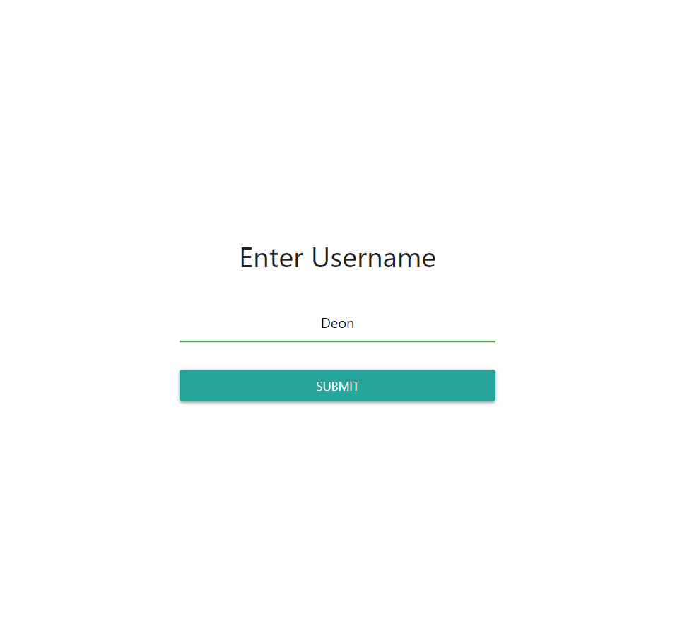

<!DOCTYPE html><html><head><meta charset="ISO-8859-1" /><link rel="stylesheet" href="https://cdnjs.cloudflare.com/ajax/libs/materialize/1.0.0/css/materialize.min.css" /> <script defer src="https://cdnjs.cloudflare.com/ajax/libs/materialize/1.0.0/js/materialize.min.js" ></script> <title>Experiment 22</title></head><style>.container{padding:15px;width:100vw;height:100vh;display:flex;flex-direction:column;justify-content:center;align-items:center}.row{width:100%;margin:5px 0px 5px 0px}.col{display:flex;flex-direction:column;justify-content:center;align-items:center}#username{width:50%;text-align:center}::placeholder{text-align:center}input[type="submit"]{width:100%;color:white}.btn{width:50%}</style><body><form action="GetLength" method="GET" class="container"><div class="row"><div class="col s12"><h4>Enter Username</h4></div></div><div class="row"><div class="input-field col s12"> <input id="username" name="username" type="text" class="validate" placeholder="Username" /></div></div><div class="row"><div class="col s12"> <input type="submit" class="waves-effect waves-light btn" value="Submit" /></div></div></form></body></html>

**AuthenticationServlet.java**

import java.io.IOException;

import java.io.PrintWriter;

import javax.servlet.ServletException;

import javax.servlet.http.HttpServlet;

import javax.servlet.http.HttpServletRequest;

import javax.servlet.http.HttpServletResponse;

public class AthenticationServlet extends HttpServlet {

protected void doPost(HttpServletRequest request, HttpServletResponse response)

throws ServletException, IOException {

response.setContentType("text/html;charset=UTF-8");

PrintWriter out = response.getWriter();

String pass = "abhishek12345";

String username, password;

username = request.getParameter("username");

password = request.getParameter("password");

if (username.equals(uname) && password.equals(pass)) {

out.println("Login Successfull");

} else {

out.println("Login Unsuccessfull");

}

}

}

**index.html**

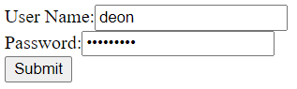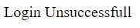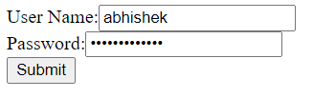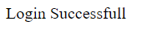

<html> <body>

<form action="AthenticationServlet”

method=”POST”>

User Name:<input type="text" name="username"><br>

Password:<input type="password" name="password" ><br>

<input type="submit">

</form>

</body><html>

**ReturnMarks.java**

import java.io.*;

import javax.servlet.*;

import javax.servlet.annotation.WebServlet;

import javax.servlet.http.*;

@WebServlet("/ReturnMarks")

public class ReturnMarks extends HttpServlet {

private static final long serialVersionUID = 1L;

public ReturnMarks() {

super();

}

protected void doGet(HttpServletRequest request, HttpServletResponse response)

throws ServletException, IOException {

response.setContentType("text/html");

PrintWriter pw = response.getWriter();

String name = request.getParameter("name");

String department = request.getParameter("department");

float percentage = Float.parseFloat(request.getParameter("percentage"));

String year = request.getParameter("year");

pw.println("<link rel='stylesheet' href='https://cdn.jsdelivr.net/npm/bootstrap@4.5.3/dist/css/bootstrap.min.css' integrity='sha384-TX8t27EcRE3e/ihU7zmQxVncDAy5uIKz4rEkgIXeMed4M0jlfIDPvg6uqKI2xXr2' crossorigin='anonymous' /> <script defer src='https://code.jquery.com/jquery-3.5.1.slim.min.js' integrity='sha384-DfXdz2htPH0lsSSs5nCTpuj/zy4C+OGpamoFVy38MVBnE+IbbVYUew+OrCXaRkfj' crossorigin='anonymous' ></script> <script defer src='https://cdn.jsdelivr.net/npm/bootstrap@4.5.3/dist/js/bootstrap.bundle.min.js' integrity='sha384-ho+j7jyWK8fNQe+A12Hb8AhRq26LrZ/JpcUGGOn+Y7RsweNrtN/tE3MoK7ZeZDyx' crossorigin='anonymous' ></script> <style>.main{width:100vw;height:100vh;display:flex;justify-content:center;align-items:center}.card{text-align:center}.row{margin-bottom:5px;margin-top:5px}</style><div class='container main'><div class='card' style='width: 500px'><div class='card-header'><h4>" + name + "</h4></div><div class='card-body'><ul class='list-group list-group-flush'></ul><li class='list-group-item'><div class='row'><div class='col-6'>Department</div><div class='col-6'>"+ department + "</div></div></li><li class='list-group-item'><div class='row'><div class='col-6'>Year</div><div class='col-6'>"+ year + "</div></div></li><li class='list-group-item'><div class='row'><div class='col-6'>Percentage</div><div class='col-6'>"+ percentage

+"</div></div></li><li class='list-group-item'><div class='row'><div class='col-6'>Status</div><div class='col-6'>"+ (percentage > 35 ? "Passed" : "Failed") + "</div></div></li></ul></div></div></div>");

pw.close();

}

protected void doPost(HttpServletRequest request, HttpServletResponse response)

throws ServletException, IOException {

doGet(request, response);

}

}

**index.html**

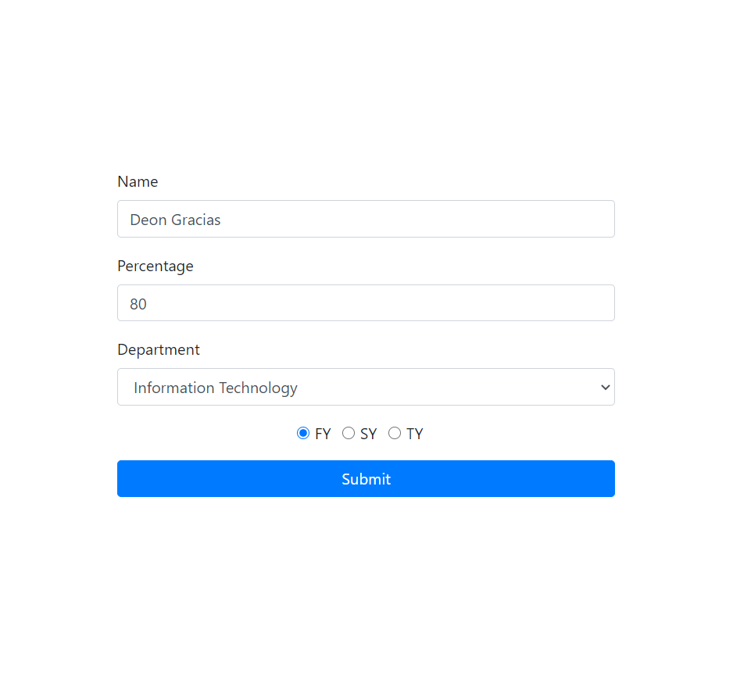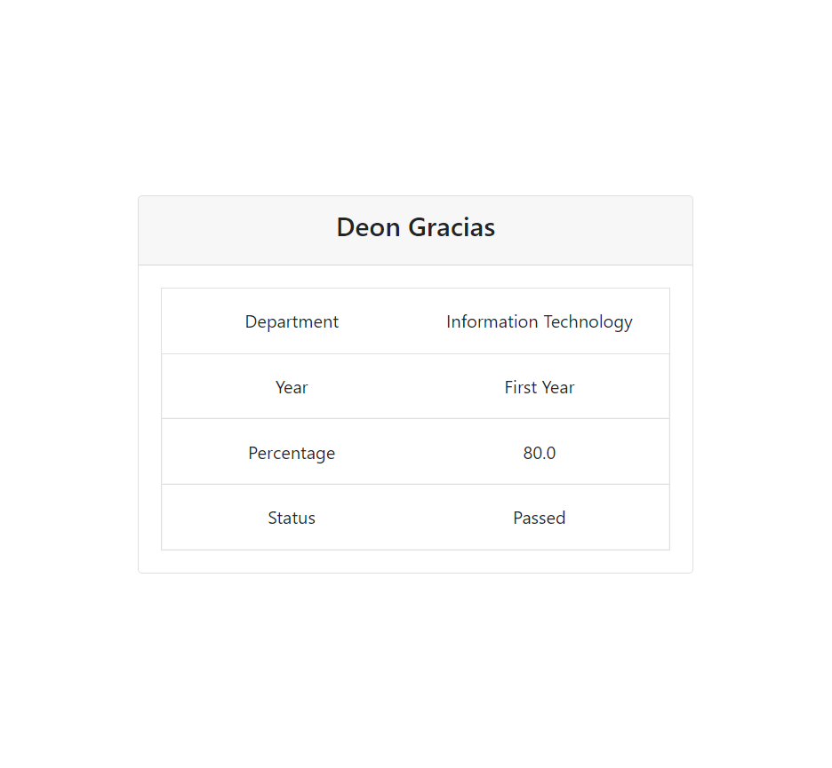

<!DOCTYPE html><html><head><meta charset="ISO-8859-1" /><link rel="stylesheet" href="https://cdn.jsdelivr.net/npm/bootstrap@4.5.3/dist/css/bootstrap.min.css" integrity="sha384-TX8t27EcRE3e/ihU7zmQxVncDAy5uIKz4rEkgIXeMed4M0jlfIDPvg6uqKI2xXr2" crossorigin="anonymous" /> <script defer src="https://code.jquery.com/jquery-3.5.1.slim.min.js" integrity="sha384-DfXdz2htPH0lsSSs5nCTpuj/zy4C+OGpamoFVy38MVBnE+IbbVYUew+OrCXaRkfj" crossorigin="anonymous" ></script> <script defer src="https://cdn.jsdelivr.net/npm/bootstrap@4.5.3/dist/js/bootstrap.bundle.min.js" integrity="sha384-ho+j7jyWK8fNQe+A12Hb8AhRq26LrZ/JpcUGGOn+Y7RsweNrtN/tE3MoK7ZeZDyx" crossorigin="anonymous" ></script> <title>Experiment 22</title></head><style>.container{padding:15px;width:100vw;height:100vh;display:flex;flex-direction:column;justify-content:center;align-items:center}.form-group{width:100%}.check{display:flex;flex-direction:row;justify-content:center;align-items:center}</style><body><form action="ReturnMarks" method="GET" class="container"><div class="form-group"> <label for="name">Name</label> <input type="text" class="form-control" id="name" placeholder="Enter Name" name="name" /></div><div class="form-group"> <label for="percentage">Percentage</label> <input type="text" class="form-control" id="percentage" placeholder="Enter Percentage" name="percentage" /></div><div class="form-group"> <label for="department">Department</label> <select class="form-control" id="department" name="department"><option value="Information Technology">Information Technology</option><option value="Computer Engineering">Computer Engineering</option><option value="Civil Engineering">Civil Engineering</option><option value="Mechanical Engineering">Mechanical Engineering</option> </select></div><div class="form-group check"><div class="form-check form-check-inline"> <input class="form-check-input" type="radio" name="year" id="FY" value="First Year" checked /> <label class="form-check-label" for="FY"> FY </label></div><div class="form-check form-check-inline"> <input class="form-check-input" type="radio" name="year" id="SY" value="Second Year" /> <label class="form-check-label" for="SY"> SY </label></div><div class="form-check form-check-inline"> <input class="form-check-input" type="radio" name="year" id="TY" value="Third Year" /> <label class="form-check-label" for="TY"> TY </label></div></div><div class="form-group"> <button type="submit" class="btn btn-primary btn-block">Submit</button></div></form></body></html>

Experiment 24

# Theory

Write the methods of Cookie.

* public void setMaxAge(int expiry) : Sets the maximum age of the cookie in seconds.
* public String getName() : Returns the name of the cookie. The name cannot be changed after creation.
* public String getValue() : Returns the value of the cookie.
* public void setName(String name) : changes the name of the cookie.
* public void setValue(String value) : changes the value of the cookie.

Write the advantages of Cookie over URL rewriting

* Sessions tracking using Cookies are more secure and fast. Session tracking using Cookies can also be used with other mechanism of Session Tracking like url rewriting.
* Cookies are stored at client side so some clients may disable cookies so we may not sure that the cookies may work or not.
* In url rewriting requites large data transfer from and to the server.
* So, it leads to network traffic and access may be become slow.

Write the steps to disable Cookie

* Go to the Browsers Settings.
* Click Show Advanced Settings or Advanced
* Click on Site Settings or Content Settings in the Privacy and Security section.
* Click on Cookies and site data.
* Click the toggle switch next to “Allow sites to save and read cookie data”.
* Click the toggle switch next to “Block Third Party Cookies”.

# Programs

# 1

Java

import java.io.*;

import javax.servlet.*;

import javax.servlet.annotation.WebServlet;

@WebServlet("/Cookies")

public class Cookies extends HttpServlet {

private static final long serialVersionUID = 1L;

public Cookies() {

super();

// TODO Auto-generated constructor stub

}

protected void doGet(HttpServletRequest request, HttpServletResponse response)

throws ServletException, IOException {

response.setContentType("text/html");

String name = request.getParameter("name");

String orderedCookie = request.getParameter("orderedCookie");

String quantity = request.getParameter("quantity");

response.addCookie(new Cookie("name", name));

response.addCookie(new Cookie("orderedCookie", orderedCookie));

response.addCookie(new Cookie("quantity", quantity));

PrintWriter pw = response.getWriter();

pw.println(

"<link rel='stylesheet' href='https://cdn.jsdelivr.net/npm/bootstrap@4.5.3/dist/css/bootstrap.min.css' integrity='sha384-TX8t27EcRE3e/ihU7zmQxVncDAy5uIKz4rEkgIXeMed4M0jlfIDPvg6uqKI2xXr2' crossorigin='anonymous' /> <script defer src='https://code.jquery.com/jquery-3.5.1.slim.min.js' integrity='sha384-DfXdz2htPH0lsSSs5nCTpuj/zy4C+OGpamoFVy38MVBnE+IbbVYUew+OrCXaRkfj' crossorigin='anonymous' ></script> <script defer src='https://cdn.jsdelivr.net/npm/bootstrap@4.5.3/dist/js/bootstrap.bundle.min.js' integrity='sha384-ho+j7jyWK8fNQe+A12Hb8AhRq26LrZ/JpcUGGOn+Y7RsweNrtN/tE3MoK7ZeZDyx' crossorigin='anonymous' ></script><div class='container'><h1 style='text-align:center'>Ordered Cookie</h1><table class='table table-bordered'><thead class='thead-dark'><tr><th scope='col'>Name</th><th scope='col'>Value</th></tr></thead><tbody>");

Cookie[] cookies = request.getCookies();

for (Cookie cookie : cookies) {

String cookieName = cookie.getName();

String cookieValue = cookie.getValue();

pw.println("<tr><td scope='row'>" + cookieName + "</td><td>" + cookieValue + "</td></tr>");

}

pw.println("</tbody></div></div>");

for (Cookie cookie : cookies) {

cookie.setValue("");

cookie.setMaxAge(0);

response.addCookie(cookie);

}

}

protected void doPost(HttpServletRequest request, HttpServletResponse response)

throws ServletException, IOException {

doGet(request, response);

}

}

HTML

<!DOCTYPE html>

<html>

<head>

<meta charset="ISO-8859-1" />

<title>Cookies</title>

<link

rel="stylesheet"

href="https://cdn.jsdelivr.net/npm/bootstrap@4.5.3/dist/css/bootstrap.min.css"

integrity="sha384-TX8t27EcRE3e/ihU7zmQxVncDAy5uIKz4rEkgIXeMed4M0jlfIDPvg6uqKI2xXr2"

crossorigin="anonymous"

/>

<script defer

src="https://code.jquery.com/jquery-3.5.1.slim.min.js"

integrity="sha384-DfXdz2htPH0lsSSs5nCTpuj/zy4C+OGpamoFVy38MVBnE+IbbVYUew+OrCXaRkfj"

crossorigin="anonymous"

></script>

<script defer

src="https://cdn.jsdelivr.net/npm/bootstrap@4.5.3/dist/js/bootstrap.bundle.min.js"

integrity="sha384-ho+j7jyWK8fNQe+A12Hb8AhRq26LrZ/JpcUGGOn+Y7RsweNrtN/tE3MoK7ZeZDyx"

crossorigin="anonymous"

></script>

</head>

<style>

#main {

width: 100vw;

height: 100vh;

display: flex;

justify-content: center;

align-items: center;

}

.card {

box-shadow: 4px 4px 10px 3px rgba(0, 0, 0, 0.2);

width: 500px;

}

</style>

<body>

<div class="container" id="main">

<form

action="Cookies"

method="get"

class="card"

>

<h5 class="card-header">Order a Cookie</h5>

<div class="card-body">

<div class="form-group">

<label for="name">Your Name</label>

<input type="text" name="name" class="form-control" />

</div>

<div class="form-group">

<label for="orderedCookie">Type of Cookie</label>

<select class="form-control" id="orderedCookie" name="orderedCookie">

<option

value="ChocolateChipCookies"

>

Chocolate Chip Cookies

</option>

<option value="Snickerdoodles">Snickerdoodles</option>

<option value="Gingersnaps">Gingersnaps</option>

<option value="PeanutButterCookies">

Peanut Butter Cookies

</option>

<option value="Biscotti">Biscotti</option>

<option value="ButterCookies">Butter Cookies</option>

</select>

</div>

<div class="form-group">

<label for="quantity">Quantity</label>

<input

type="text"

name="quantity"

id="quantity"

class="form-control"

/>

</div>

<div class="form-group">

<button id="submit-btn" type="submit" class="btn btn-primary">

Order

</button>

</div>

</div>

</form>

</div>

</body>

</html>

Outputs

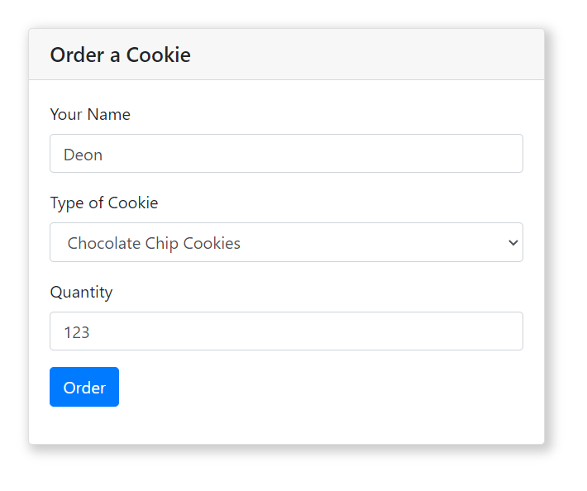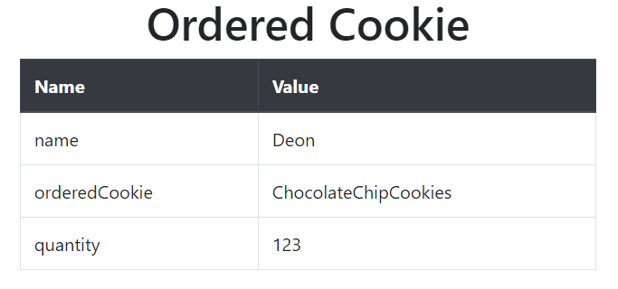

# 2

Java

FirstServlet.java

import java.io.IOException;

import java.io.PrintWriter;

import javax.servlet.ServletException;

import javax.servlet.annotation.WebServlet;

import javax.servlet.http.Cookie;

import javax.servlet.http.HttpServlet;

import javax.servlet.http.HttpServletRequest;

import javax.servlet.http.HttpServletResponse;

@WebServlet("/FirstServlet")

public class FirstServlet extends HttpServlet {

protected void doPost(HttpServletRequest request, HttpServletResponse response)

throws ServletException, IOException {

try {

response.setContentType("text/html");

PrintWriter out = response.getWriter();

String n = request.getParameter("userName");

out.print("Welcome " + n);

Cookie ck = new Cookie("uname", n);

response.addCookie(ck);

out.print("<form action='SecondServlet'>");

out.print("<input type='submit' value='go'/>");

out.print("</form>");

out.close();

} catch (Exception e) {

System.out.println(e);

}

}

}

SecondServlet.java

import java.io.IOException;

import java.io.PrintWriter;

import javax.servlet.ServletException;

import javax.servlet.annotation.WebServlet;

import javax.servlet.http.Cookie;

import javax.servlet.http.HttpServlet;

import javax.servlet.http.HttpServletRequest;

import javax.servlet.http.HttpServletResponse;

@WebServlet("/SecondServlet")

public class SecondServlet extends HttpServlet {

protected void doGet(HttpServletRequest request, HttpServletResponse response)

throws ServletException, IOException {

response.setContentType("text/html");

try {

response.setContentType("text/html");

PrintWriter out = response.getWriter();

Cookie ck[] = request.getCookies();

out.print("Hello " + ck[0].getValue());

out.close();

} catch (Exception e) {

System.out.println(e);

}

}

}

Html

<form action="FirstServlet" method="post">

Name:<input type="text" name="userName" /><br/>

<input type="submit" value="go">

</form>

Outputs

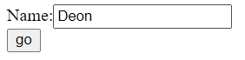

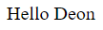

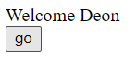

# 3

Java

import java.io.IOException;

import java.io.PrintWriter;

import javax.servlet.ServletException;

import javax.servlet.annotation.WebServlet;

import javax.servlet.http.Cookie;

import javax.servlet.http.HttpServlet;

import javax.servlet.http.HttpServletRequest;

import javax.servlet.http.HttpServletResponse;

@WebServlet("/Cookies")

public class Cookies extends HttpServlet {

private static final long serialVersionUID = 1L;

public Cookies() {

super();

// TODO Auto-generated constructor stub

}

protected void doGet(HttpServletRequest request, HttpServletResponse response)

throws ServletException, IOException {

response.setContentType("text/html");

String name = request.getParameter("name");

String orderedCookie = request.getParameter("orderedCookie");

String quantity = request.getParameter("quantity");

response.addCookie(new Cookie("name", name));

response.addCookie(new Cookie("orderedCookie", orderedCookie));

response.addCookie(new Cookie("quantity", quantity));

PrintWriter pw = response.getWriter();

pw.println(

"<link rel='stylesheet' href='https://cdn.jsdelivr.net/npm/bootstrap@4.5.3/dist/css/bootstrap.min.css' integrity='sha384-TX8t27EcRE3e/ihU7zmQxVncDAy5uIKz4rEkgIXeMed4M0jlfIDPvg6uqKI2xXr2' crossorigin='anonymous' /> <script defer src='https://code.jquery.com/jquery-3.5.1.slim.min.js' integrity='sha384-DfXdz2htPH0lsSSs5nCTpuj/zy4C+OGpamoFVy38MVBnE+IbbVYUew+OrCXaRkfj' crossorigin='anonymous' ></script> <script defer src='https://cdn.jsdelivr.net/npm/bootstrap@4.5.3/dist/js/bootstrap.bundle.min.js' integrity='sha384-ho+j7jyWK8fNQe+A12Hb8AhRq26LrZ/JpcUGGOn+Y7RsweNrtN/tE3MoK7ZeZDyx' crossorigin='anonymous' ></script><div class='container'><h1 style='text-align:center'>Ordered Cookie</h1><table class='table table-bordered'><thead class='thead-dark'><tr><th scope='col'>Name</th><th scope='col'>Value</th></tr></thead><tbody>");

Cookie[] cookies = request.getCookies();

for (Cookie cookie : cookies) {

String cookieName = cookie.getName();

String cookieValue = cookie.getValue();

pw.println("<tr><td scope='row'>" + cookieName + "</td><td>" + cookieValue + "</td></tr>");

}

pw.println("</tbody></div></div>");

for (Cookie cookie : cookies) {

cookie.setValue("");

cookie.setMaxAge(0);

response.addCookie(cookie);

}

}

protected void doPost(HttpServletRequest request, HttpServletResponse response)

throws ServletException, IOException {

doGet(request, response);

}

}

Html

<!DOCTYPE html>

<html>

<head>

<meta charset="ISO-8859-1" />

<title>Cookies</title>

<link

rel="stylesheet"

href="https://cdn.jsdelivr.net/npm/bootstrap@4.5.3/dist/css/bootstrap.min.css"

integrity="sha384-TX8t27EcRE3e/ihU7zmQxVncDAy5uIKz4rEkgIXeMed4M0jlfIDPvg6uqKI2xXr2"

crossorigin="anonymous"

/>

<script defer

src="https://code.jquery.com/jquery-3.5.1.slim.min.js"

integrity="sha384-DfXdz2htPH0lsSSs5nCTpuj/zy4C+OGpamoFVy38MVBnE+IbbVYUew+OrCXaRkfj"

crossorigin="anonymous"

></script>

<script defer

src="https://cdn.jsdelivr.net/npm/bootstrap@4.5.3/dist/js/bootstrap.bundle.min.js"

integrity="sha384-ho+j7jyWK8fNQe+A12Hb8AhRq26LrZ/JpcUGGOn+Y7RsweNrtN/tE3MoK7ZeZDyx"

crossorigin="anonymous"

></script>

</head>

<style>

#main {

width: 100vw;

height: 100vh;

display: flex;

justify-content: center;

align-items: center;

}

.card {

box-shadow: 4px 4px 10px 3px rgba(0, 0, 0, 0.2);

width: 500px;

}

</style>

<body>

<div class="container" id="main">

<form

action="Cookies"

method="get"

class="card"

>

<h5 class="card-header">Order a Cookie</h5>

<div class="card-body">

<div class="form-group">

<label for="name">Your Name</label>

<input type="text" name="name" class="form-control" />

</div>

<div class="form-group">

<label for="orderedCookie">Type of Cookie</label>

<select class="form-control" id="orderedCookie" name="orderedCookie">

<option

value="ChocolateChipCookies"

>

Chocolate Chip Cookies

</option>

<option value="Snickerdoodles">Snickerdoodles</option>

<option value="Gingersnaps">Gingersnaps</option>

<option value="PeanutButterCookies">

Peanut Butter Cookies

</option>

<option value="Biscotti">Biscotti</option>

<option value="ButterCookies">Butter Cookies</option>

</select>

</div>

<div class="form-group">

<label for="quantity">Quantity</label>

<input

type="text"

name="quantity"

id="quantity"

class="form-control"

/>

</div>

<div class="form-group">

<button id="submit-btn" type="submit" class="btn btn-primary">

Order

</button>

</div>

</div>

</form>

</div>

</body>

</html>

Outputs



# 4

Java

import java.io.IOException;

import java.io.PrintWriter;

import javax.servlet.ServletException;

import javax.servlet.annotation.WebServlet;

import javax.servlet.http.HttpServlet;

import javax.servlet.http.HttpServletRequest;

import javax.servlet.http.HttpServletResponse;

@WebServlet("/ClientInfo")

public class ClientInfo extends HttpServlet {

private static final long serialVersionUID = 1L;

public ClientInfo() {

super();

}

protected void doGet(HttpServletRequest request, HttpServletResponse response)

throws ServletException, IOException {

response.setContentType("text/html");

PrintWriter pw = response.getWriter();

pw.println(

"<link rel='stylesheet' href='https://cdn.jsdelivr.net/npm/bootstrap@4.5.3/dist/css/bootstrap.min.css' integrity='sha384-TX8t27EcRE3e/ihU7zmQxVncDAy5uIKz4rEkgIXeMed4M0jlfIDPvg6uqKI2xXr2' crossorigin='anonymous' /> <script defer src='https://code.jquery.com/jquery-3.5.1.slim.min.js' integrity='sha384-DfXdz2htPH0lsSSs5nCTpuj/zy4C+OGpamoFVy38MVBnE+IbbVYUew+OrCXaRkfj' crossorigin='anonymous' ></script> <script defer src='https://cdn.jsdelivr.net/npm/bootstrap@4.5.3/dist/js/bootstrap.bundle.min.js' integrity='sha384-ho+j7jyWK8fNQe+A12Hb8AhRq26LrZ/JpcUGGOn+Y7RsweNrtN/tE3MoK7ZeZDyx' crossorigin='anonymous' ></script><style>.container{display:flex;align-item:center;justify-content:center;height:100vh;flex-direction:column}</style><div class='container'><h1 style='text-align:center'>Browser Info</h1><br/><table class='table table-bordered'><thead class='thead-dark'><tr><th scope='col'>Name</th><th scope='col'>Value</th></tr></thead><tbody>");

String[][] browserInfo = { { "User Agent", request.getHeader("User-Agent") },

{ "Client IP Address", request.getRemoteAddr() },

{ "Requested URL", new String(request.getRequestURL()) }, { "Client OS", getClientOS(request) } };

for (String[] info : browserInfo) {

pw.println("<tr><td scope='row'>" + info[0] + "</td><td>" + info[1] + "</td></tr>");

}

pw.println("</tbody></div>");

}

public String getClientOS(HttpServletRequest request) {

final String browserDetails = request.getHeader("User-Agent");

final String lowerCaseBrowser = browserDetails.toLowerCase();

if (lowerCaseBrowser.contains("windows")) {

return "Windows";

} else if (lowerCaseBrowser.contains("mac")) {

return "Mac";

} else if (lowerCaseBrowser.contains("x11")) {

return "Unix";

} else if (lowerCaseBrowser.contains("android")) {

return "Android";

} else if (lowerCaseBrowser.contains("iphone")) {

return "IPhone";

} else {

return "UnKnown, More-Info: " + browserDetails;

}

}

protected void doPost(HttpServletRequest request, HttpServletResponse response)

throws ServletException, IOException {

doGet(request, response);

}

}

Html

<!DOCTYPE html>

<html>

<head>

<meta charset="ISO-8859-1" />

<title>Cookies</title>

<link

rel="stylesheet"

href="https://cdn.jsdelivr.net/npm/bootstrap@4.5.3/dist/css/bootstrap.min.css"

integrity="sha384-TX8t27EcRE3e/ihU7zmQxVncDAy5uIKz4rEkgIXeMed4M0jlfIDPvg6uqKI2xXr2"

crossorigin="anonymous"

/>

<script defer

src="https://code.jquery.com/jquery-3.5.1.slim.min.js"

integrity="sha384-DfXdz2htPH0lsSSs5nCTpuj/zy4C+OGpamoFVy38MVBnE+IbbVYUew+OrCXaRkfj"

crossorigin="anonymous"

></script>

<script defer

src="https://cdn.jsdelivr.net/npm/bootstrap@4.5.3/dist/js/bootstrap.bundle.min.js"

integrity="sha384-ho+j7jyWK8fNQe+A12Hb8AhRq26LrZ/JpcUGGOn+Y7RsweNrtN/tE3MoK7ZeZDyx"

crossorigin="anonymous"

></script>

</head>

<style>

#main {

width: 100vw;

height: 100vh;

display: flex;

padding:15px;

justify-content: center;

align-items: center;

}

.btn{

width:100%;

height:100%

}

</style>

<body>

<form

action="ClientInfo"

method="get"

id="main"

>

<button id="submit-btn" type="submit" class="btn btn-danger btn-block">

<h5>Get Browser Information</h5>

</button>

</form>

</body>

</html>

Outputs



